Storytelling Case Study: Airbnb, NYC

Air BNB, Inc.

Methodology Document

Done by:

Sukeerthi G

Shubham Aggarwal

**DATA STORY TELLING: AIRBNB**

**PROBLEM STATEMENT:**

For the past few months, Airbnb has seen a major decline in revenue. Now that the restrictions have started lifting and people have started to travel more, Airbnb wants to make sure that it is fully prepared for this change.

**OBJECTIVE:**

The top management at Airbnb wants to understand some important insights based on various attributes in the dataset so as to increase the revenue.

**DATA WRANGLING:**

1. **Analysing the attributes**

The process of analyzing the data had been carried out in Jupyter Notebook.

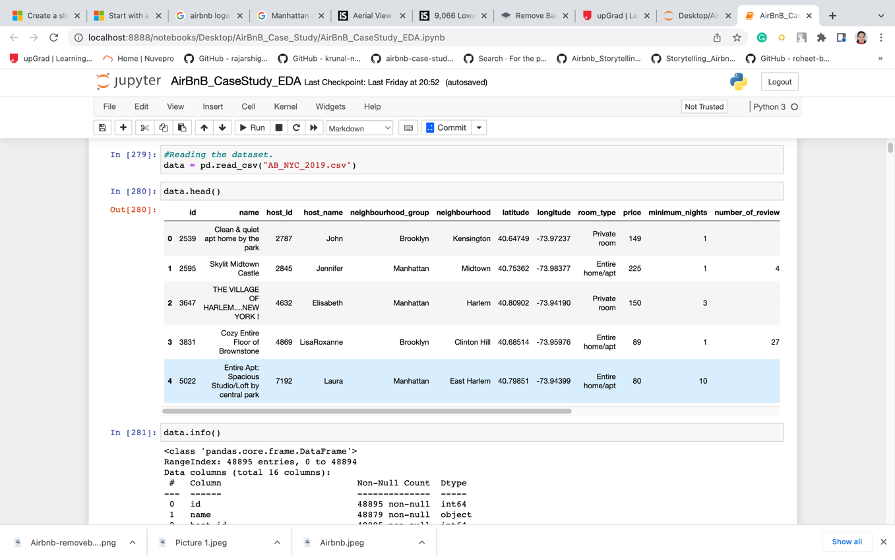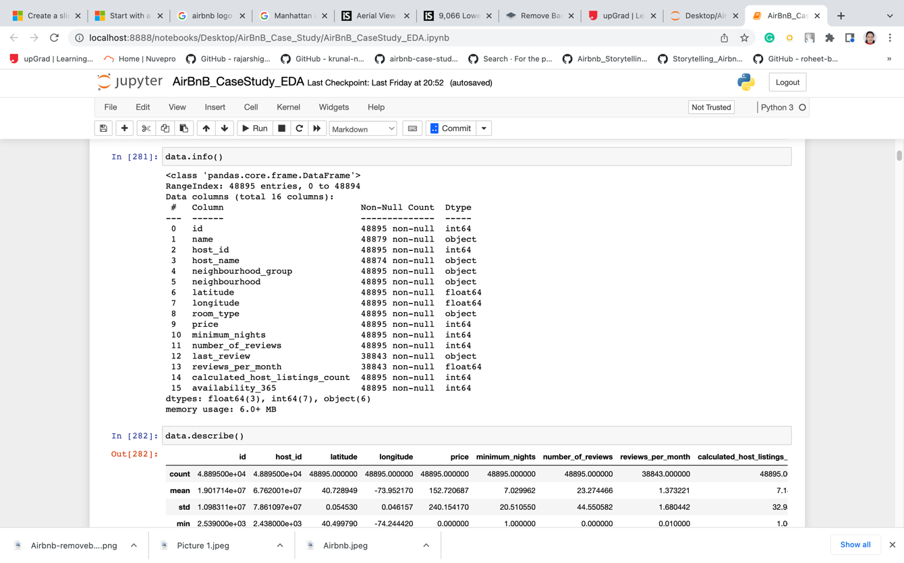

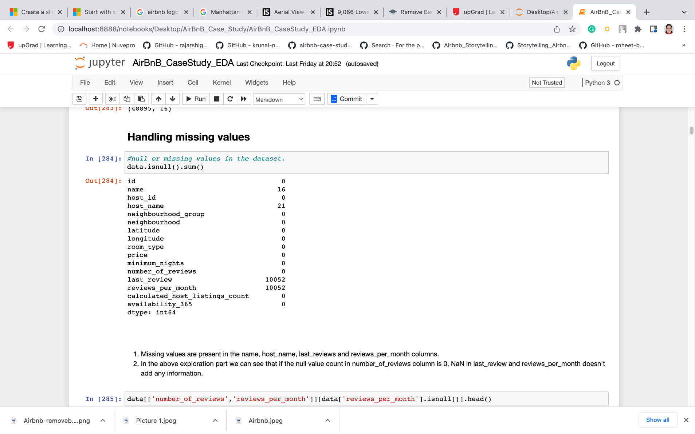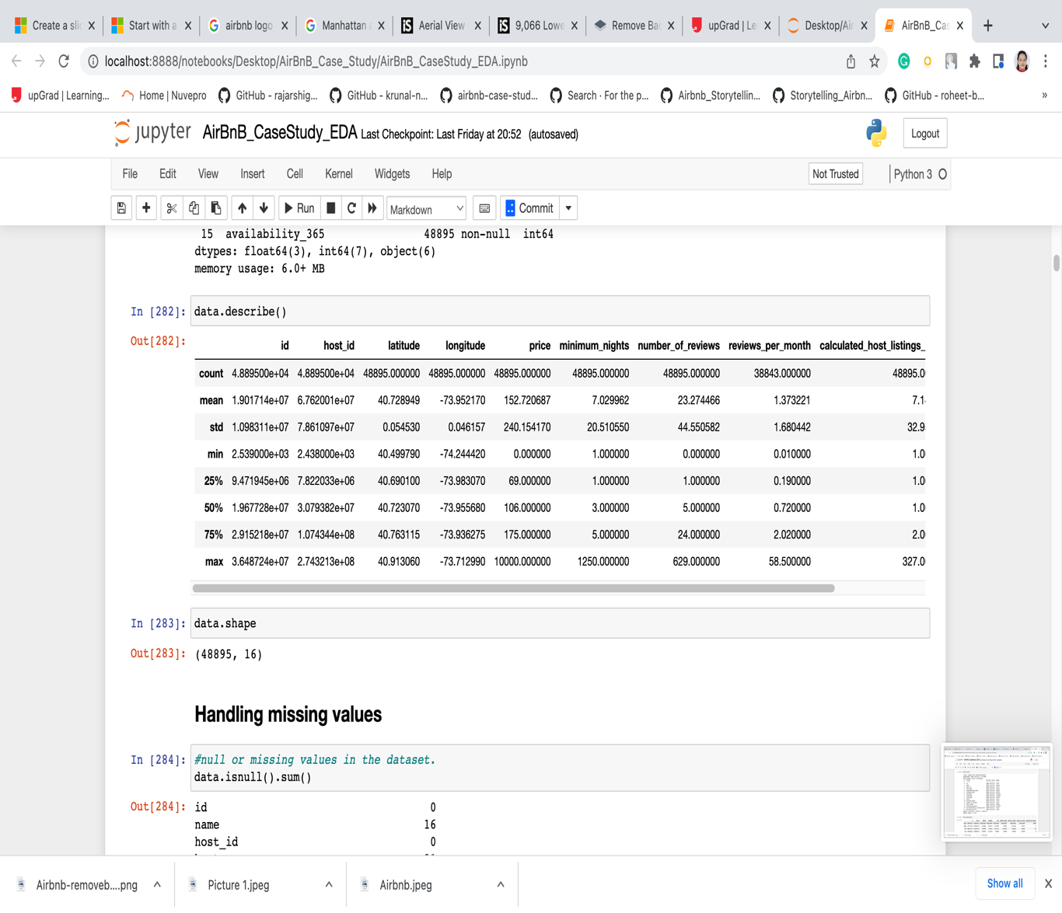

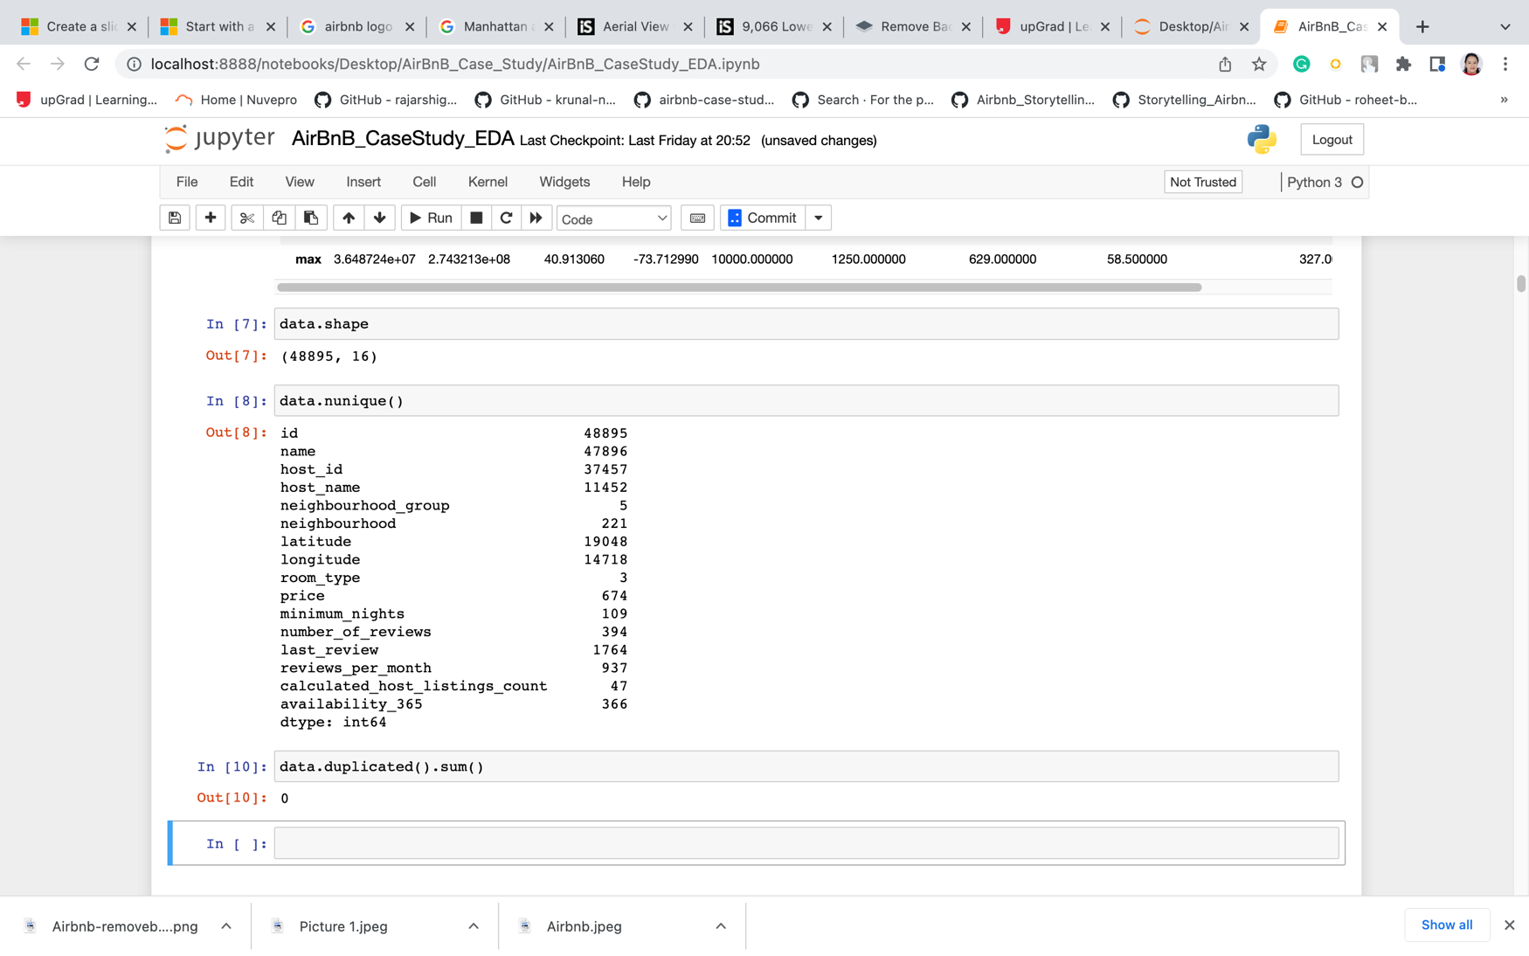

* The dataset consists of 48895 rows and 16 columns which containing various attribute regarding the Airbnb listings such as host id, name, price, room type and more. There are no duplicated values in the columns.
* There are 3 room type, 5 neighbourhood group in the datasets, out of the 5 neighbourhood group, there are total of 221 neighbourhood in the datasets. Also, there are total of 674 unique pricing in the dataset.

1. **Handling the Missing Values**

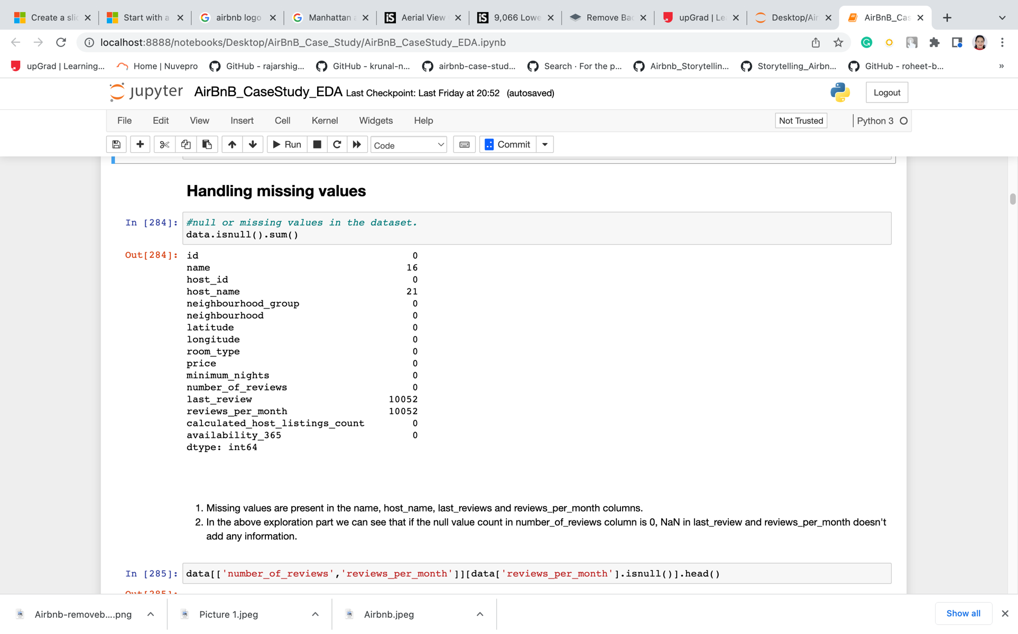

* Missing values are present in the name, host_name, last_reviews and reviews_per_month columns.
* In the above exploration part we can see that if the null value count in number_of_reviews column is 0, NaN in last_review and reviews_per_month doesn't add any information.

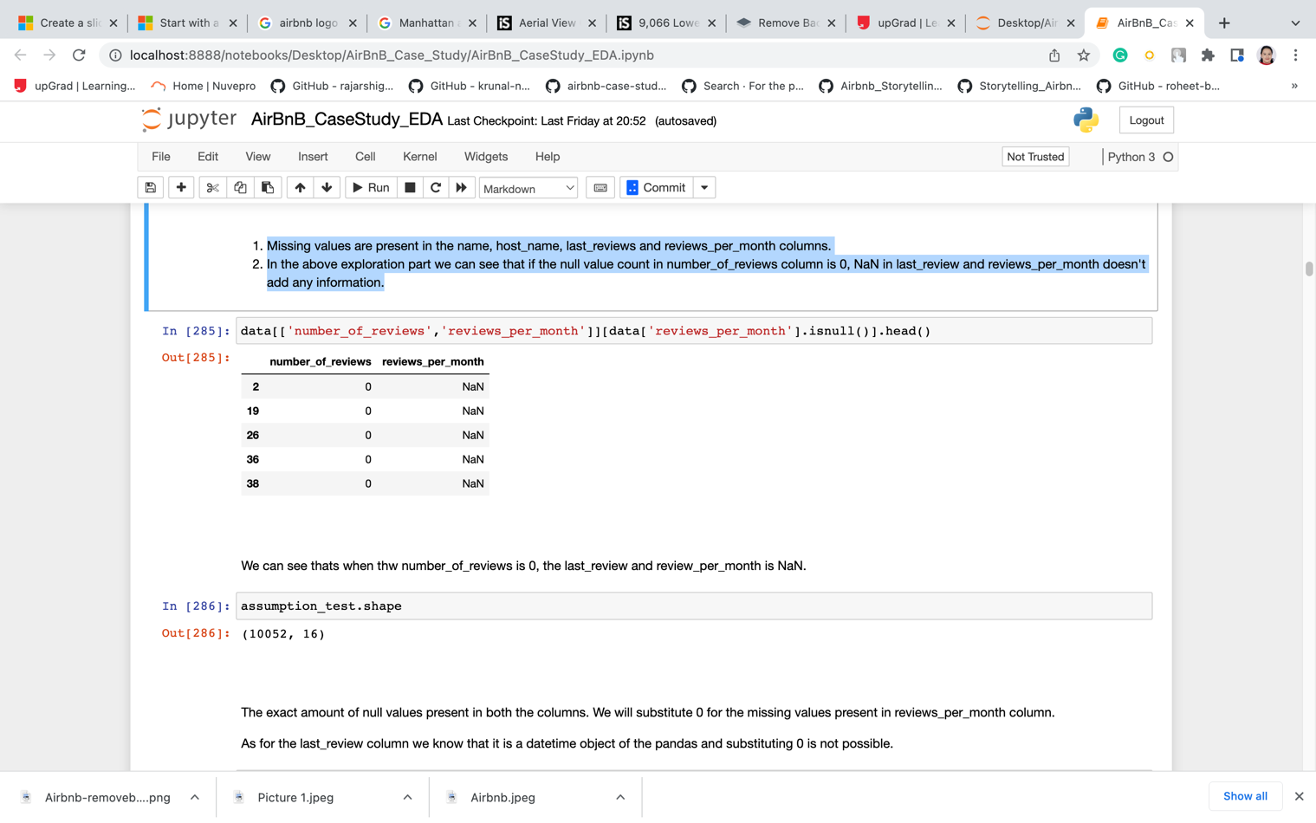

* We can see that when the number_of_reviews is 0, the last_review and review_per_month is NaN.

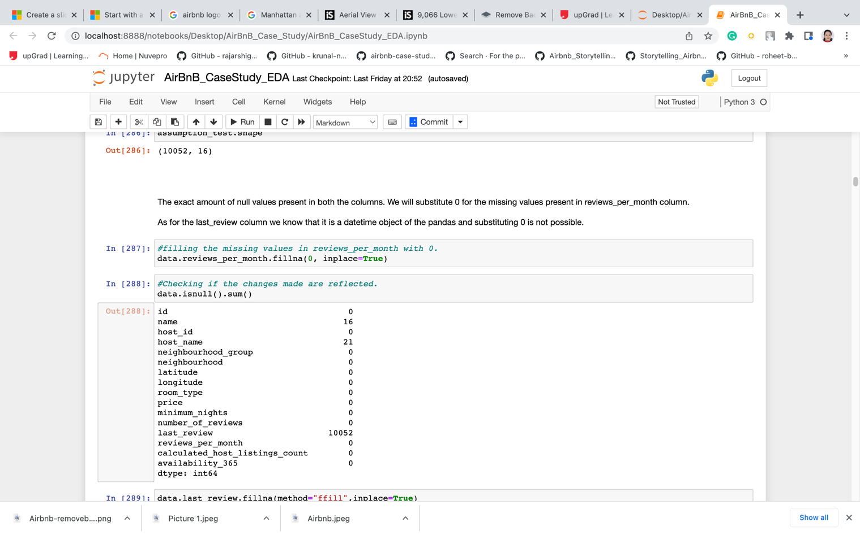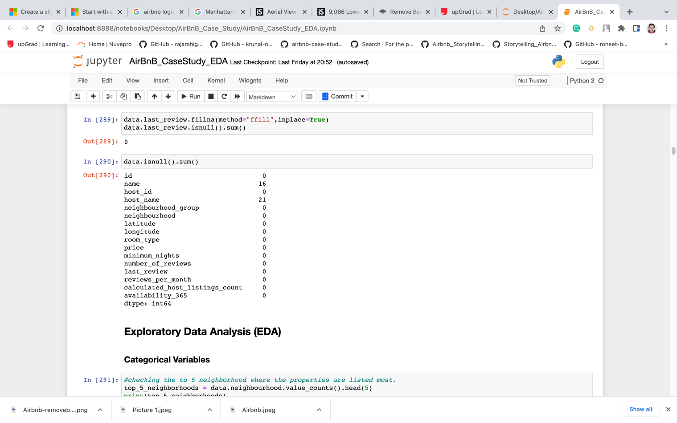

**Steps:**

1. There are totals of 4 columns with null values, which are last review, review per month, name and host name columns.
2. Missing values are present in the name, host_name, last_reviews and reviews_per_month columns.
3. In the above exploration part we can see that if the null value count in number_of_reviews column is 0, NaN in last_review and reviews_per_month doesn't add any information.
4. **Handling The Outliers:**

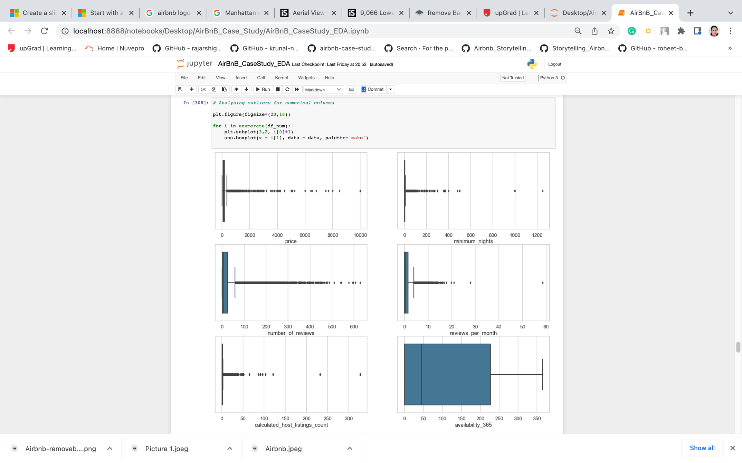

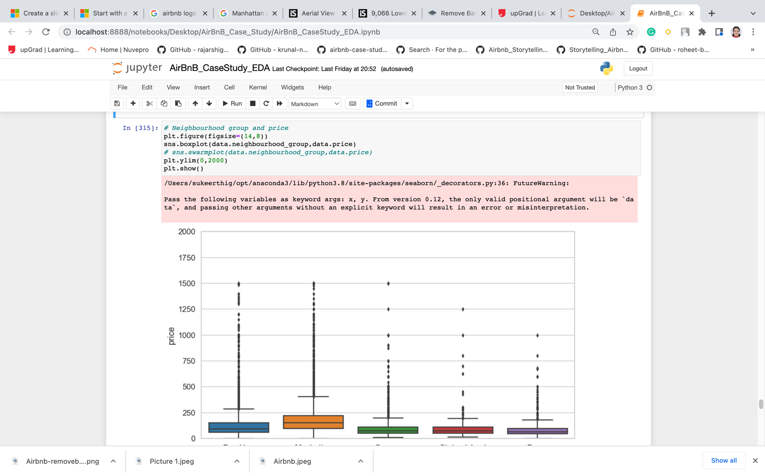

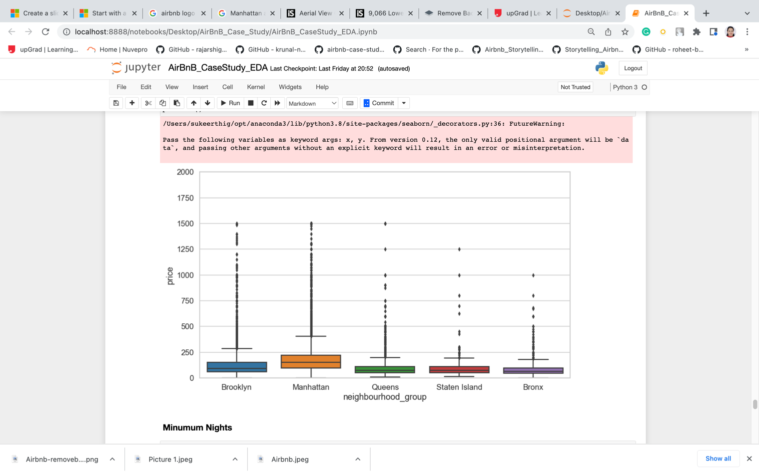

From the boxplot, we can summarize that:

* There is an obvious outlier for the price column, 10000 usd is too costly and it is unaffordable for most number of people.
* Same goes with the column minimum_nights where 1200 days which is equivalent to 3.28 years.

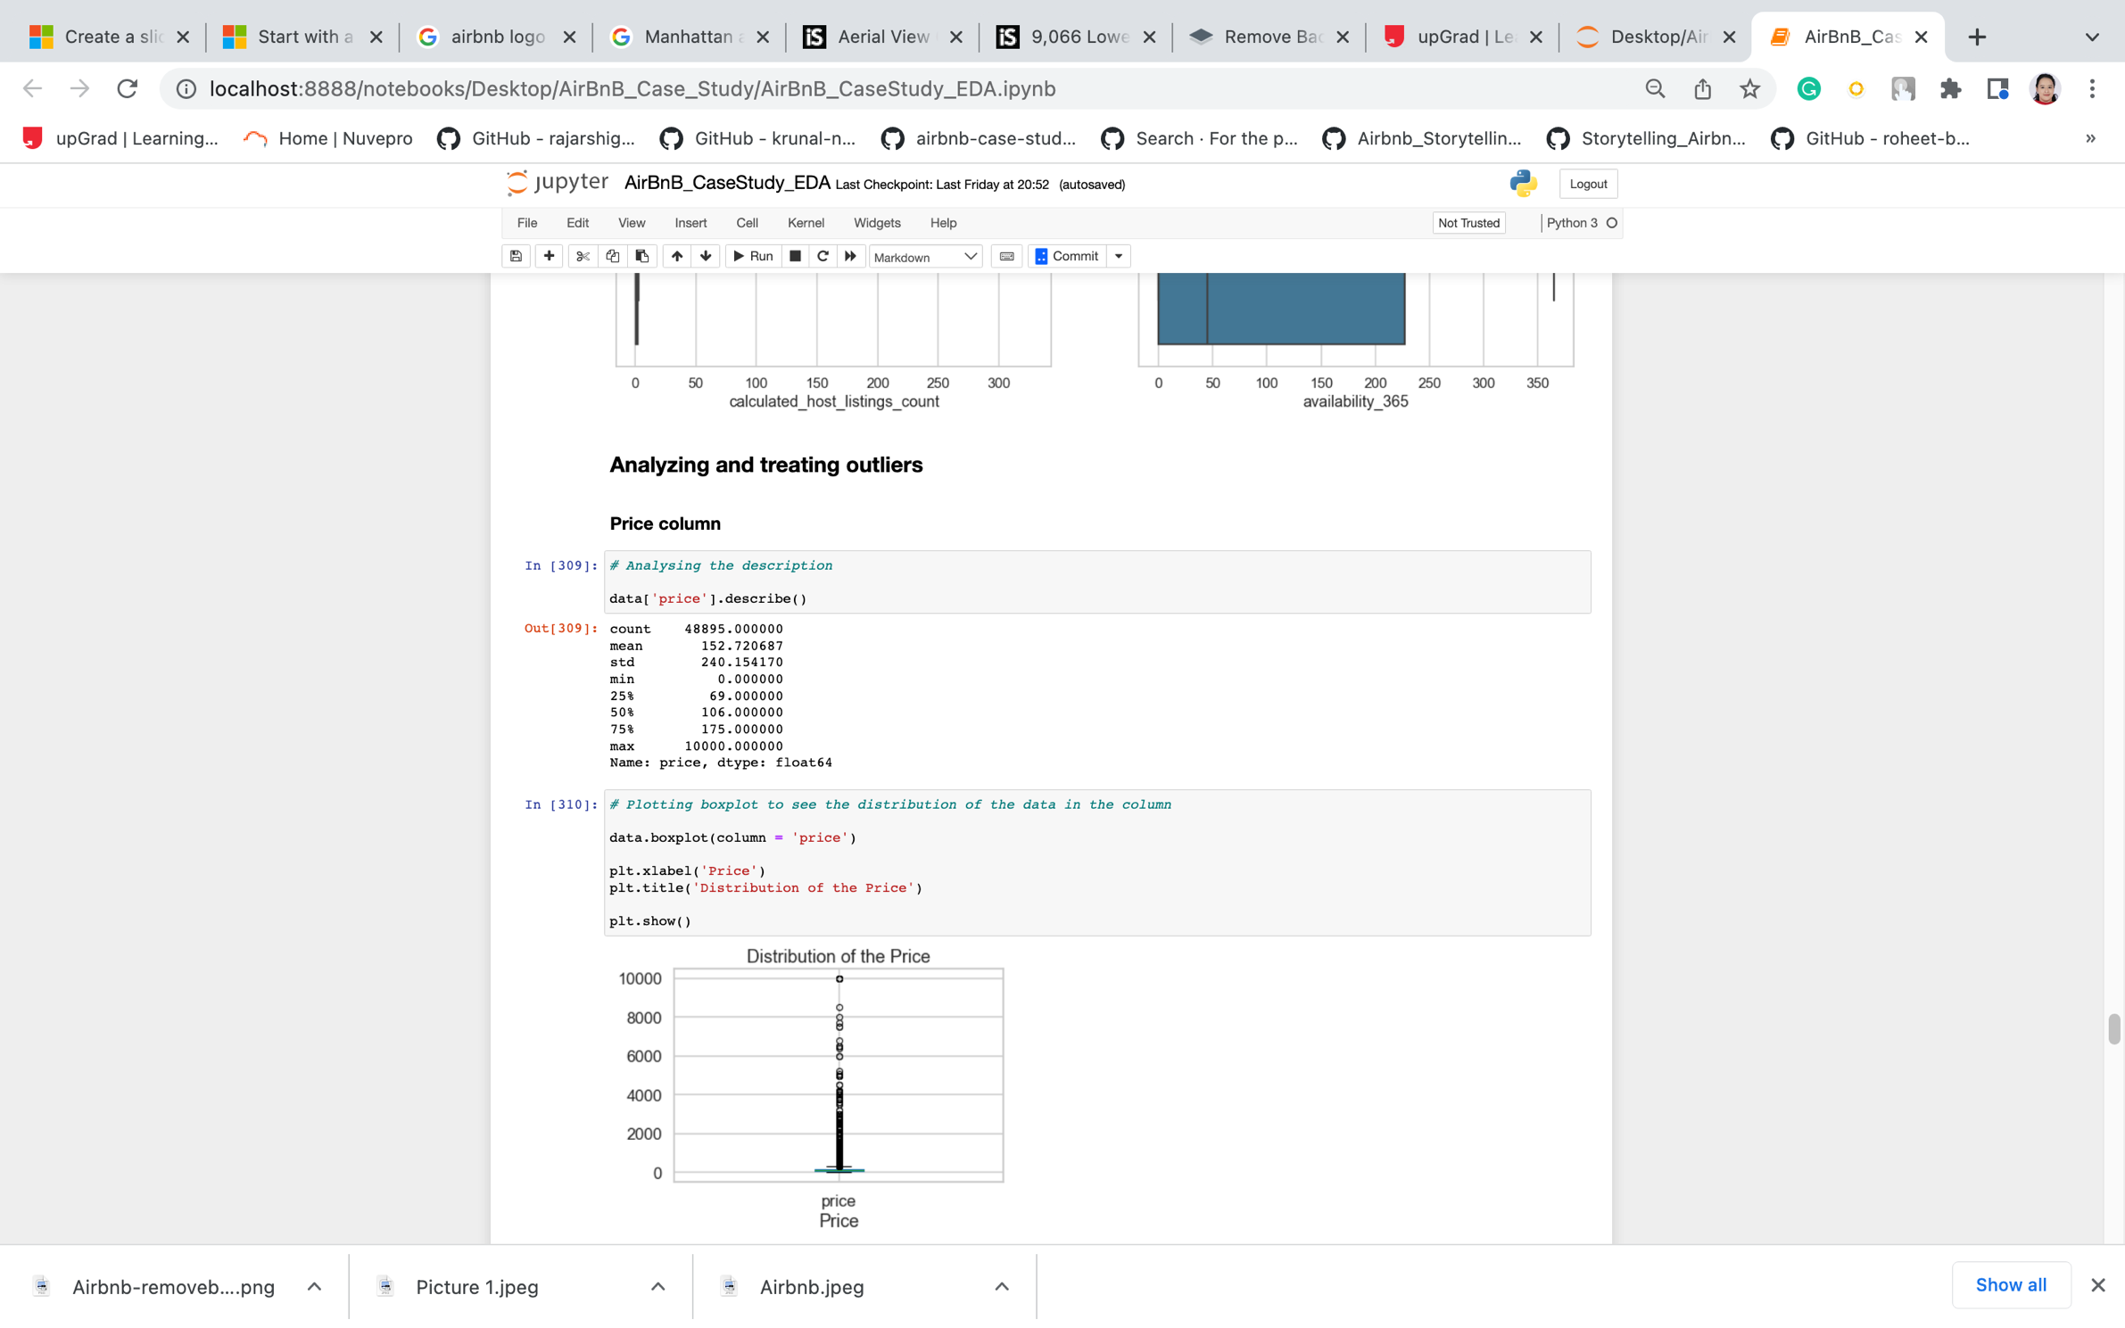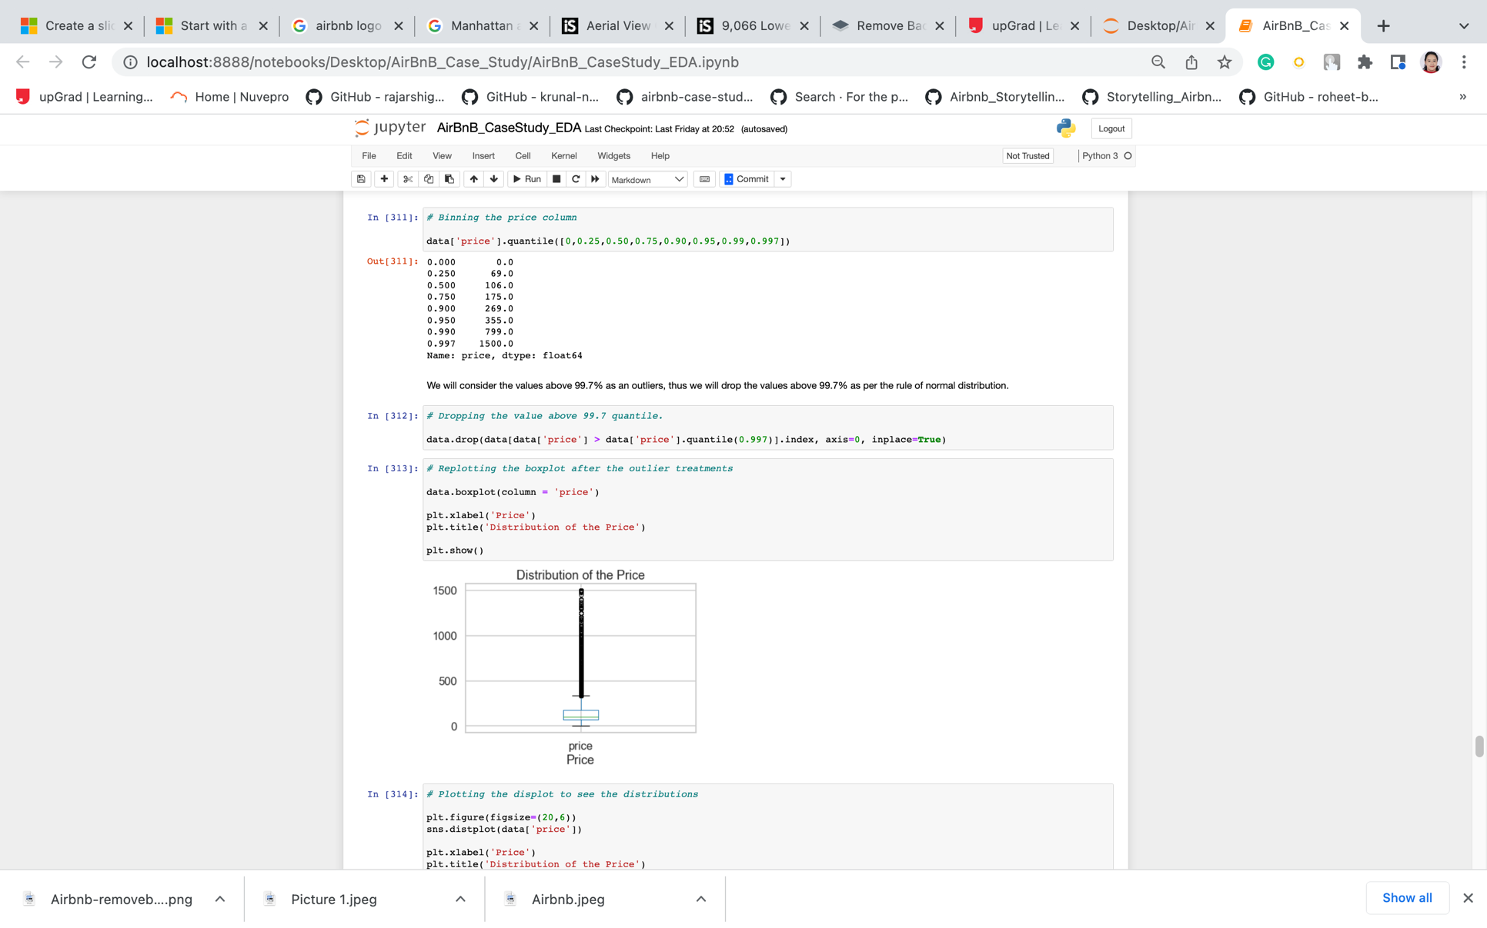

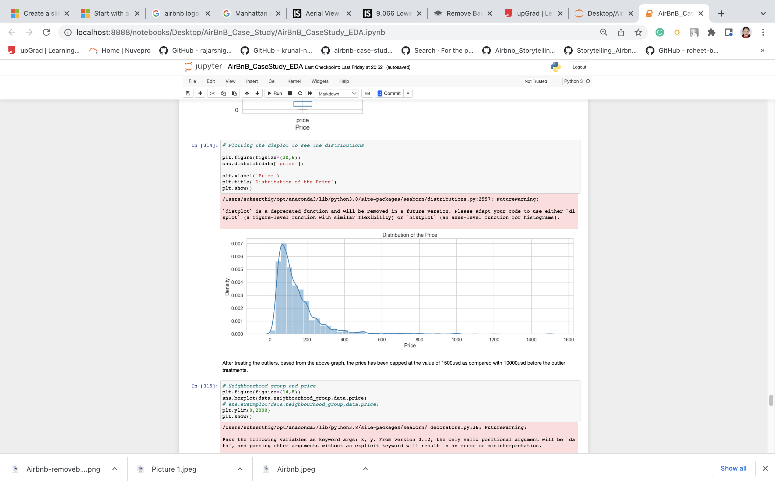



* We considered the values above 99.7% as an outliers, thus we will drop the values above 99.7% as per the rule of normal distribution.
* After treating the outliers, based from the above graph, the price has been capped at the value of 1500usd as compared with 10000usd before the outlier treatments.

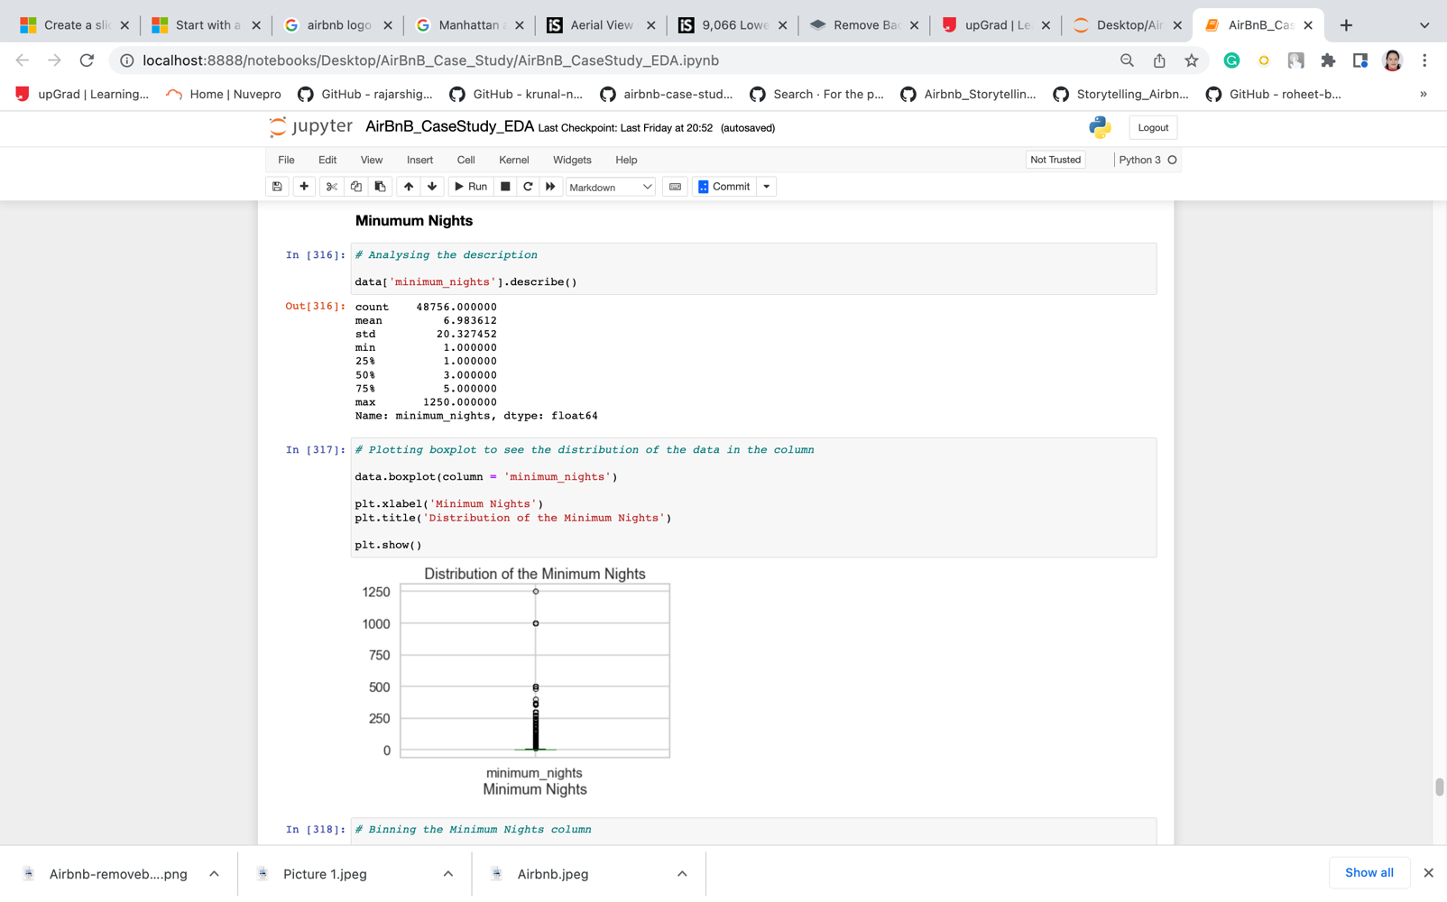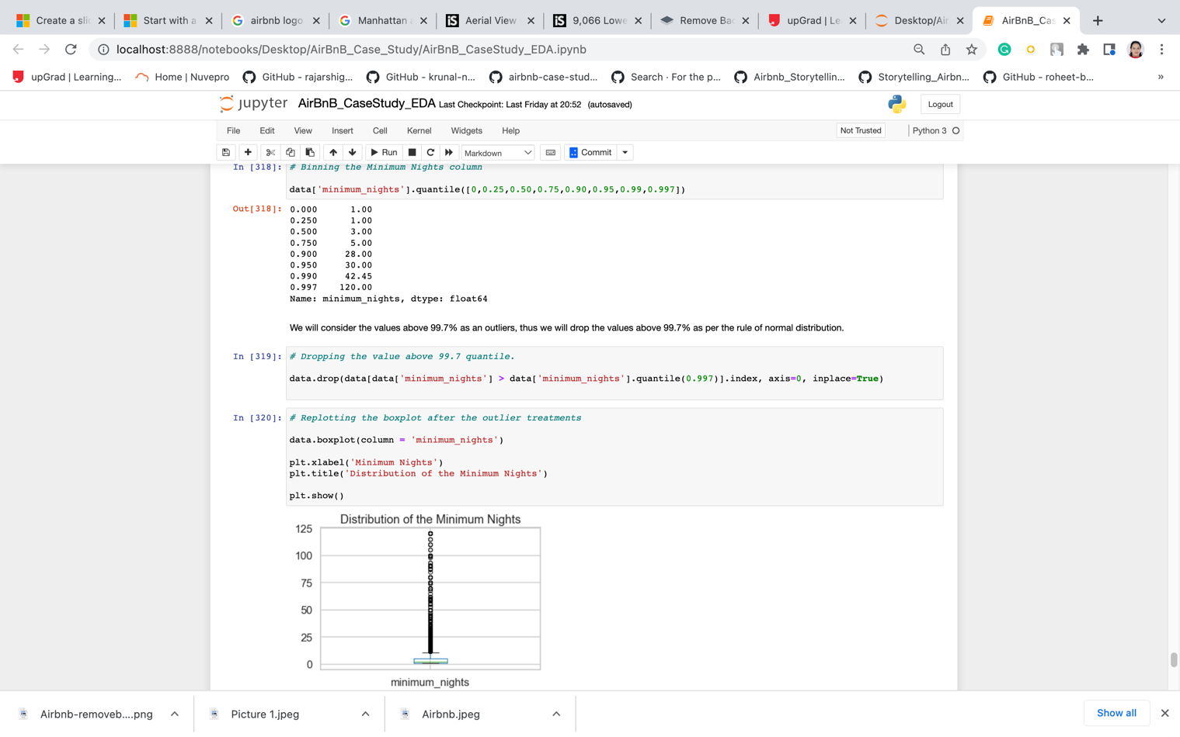

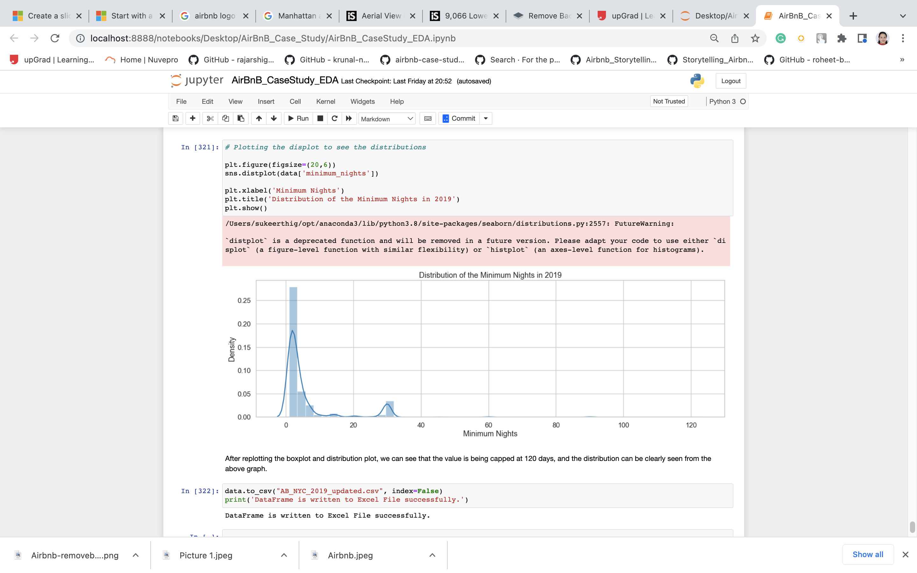



**Exploratory Data Analysis (EDA)**

1. **Univariate Analysis**

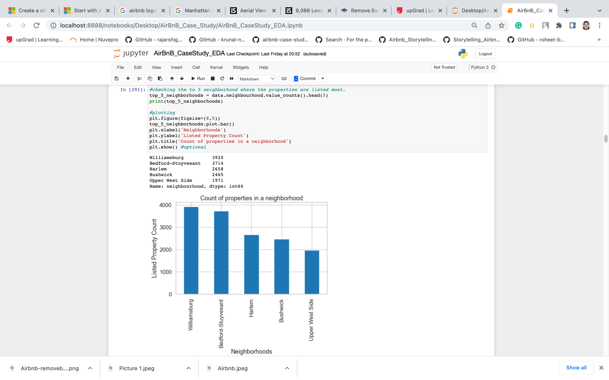

* The top 5 neighbourhoods which have the highest number of properties listed are shown above. We can see that Williamsburg has the highest number of properties listed (3920) followed by Bedford-Stuyvesant (3714).
* As Williamsburg has the highest number of properties listed

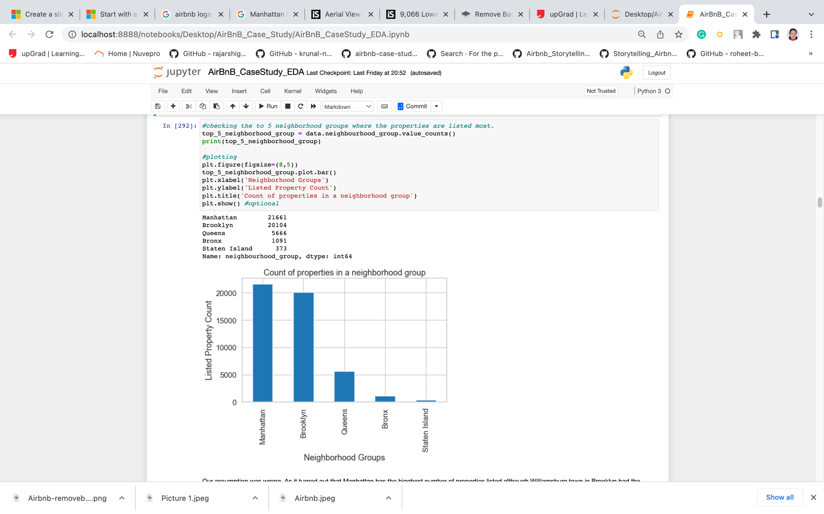

* Manhattan has the higghest number of properties listed although Williamsburg town in Brooklyn had the highest number of properties among the neighbour towns.
* This infers that there are many other towns in Manhattan that have properties listed and that is why Manhattan neighbourhood as a whole has the highest number of properties.
* We can also see that other neighbourhood groups such as Queens, Bronx and Staten Island contribute less compared to Manhattan and Brooklyn.

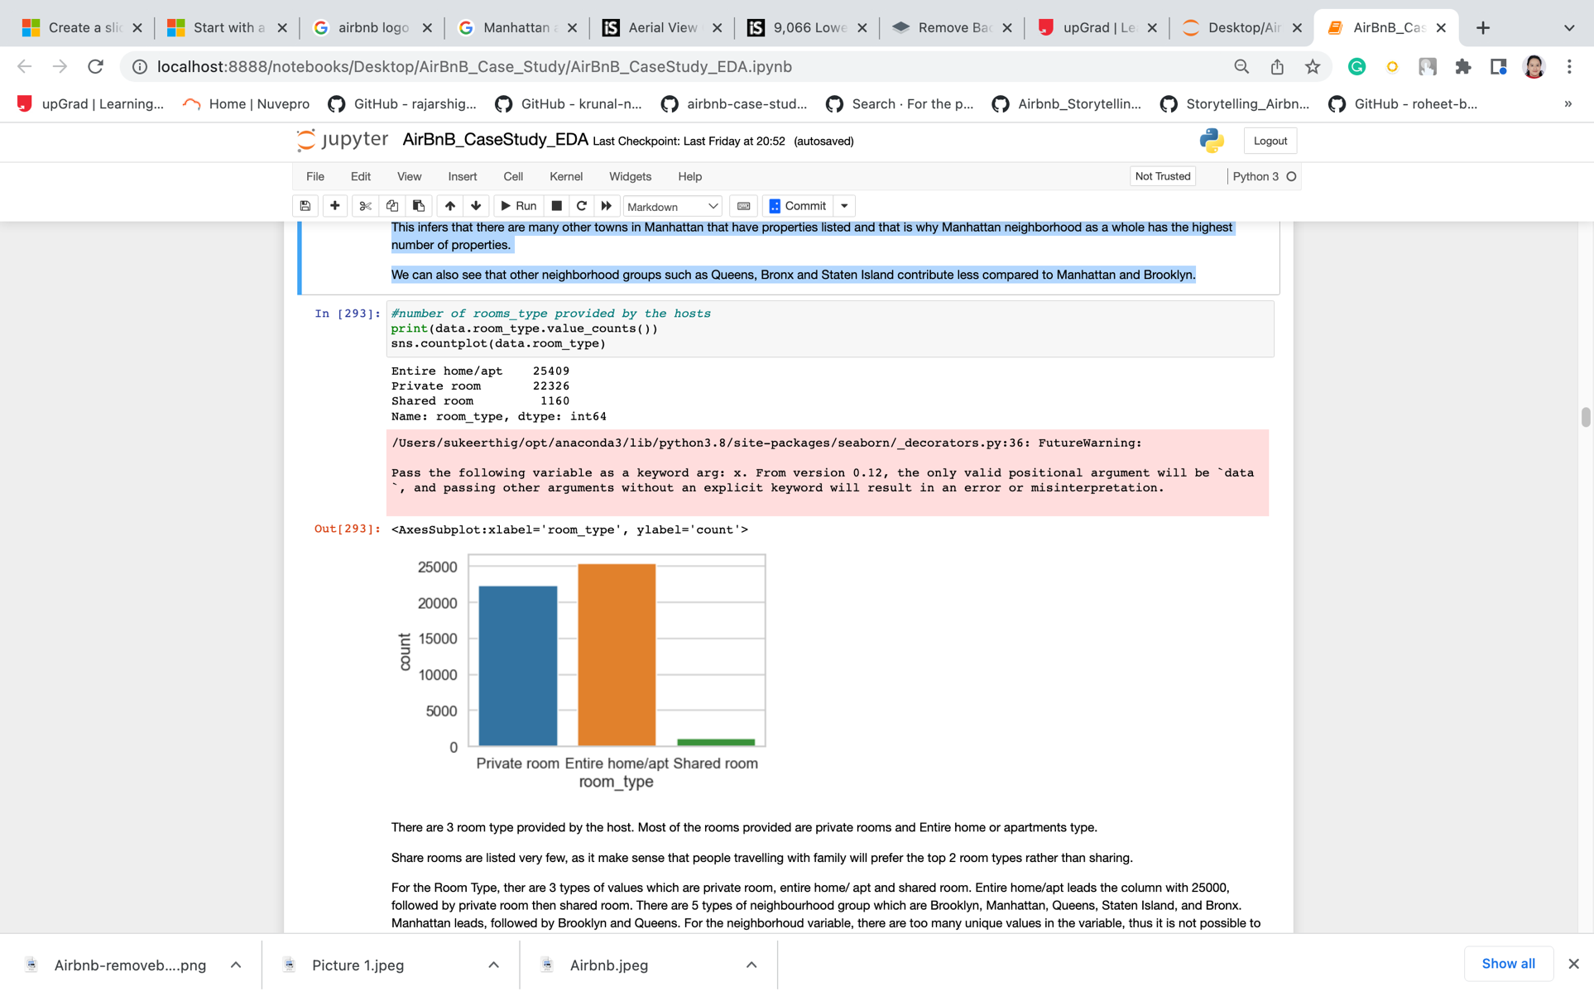

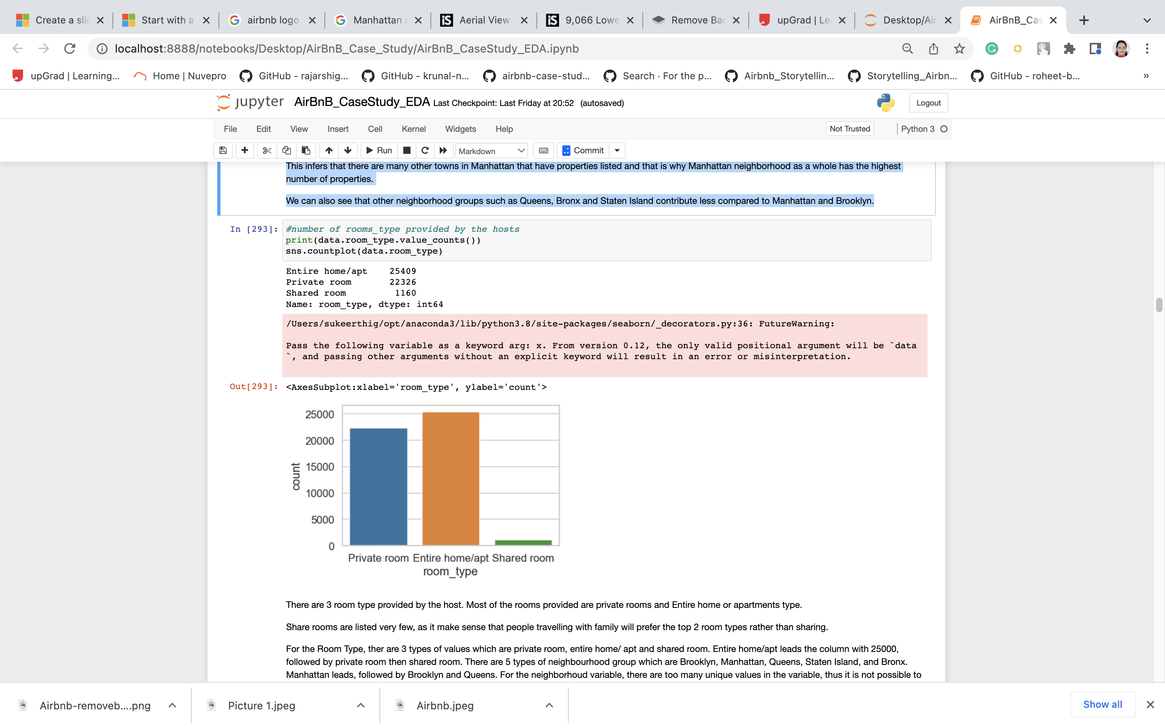

* There are 3 room type provided by the host. Most of the rooms provided are private rooms and Entire home or apartments type.
* Share rooms are listed very few, as it make sense that people travelling with family will prefer the top 2 room types rather than sharing.
* For the Room Type, there are 3 types of values which are private room, entire home/ apt and shared room. Entire home/apt leads the column with 25000, followed by private room then shared room. There are 5 types of neighbourhood group which are Brooklyn, Manhattan, Queens, Staten Island, and Bronx. Manhattan leads, followed by Brooklyn and Queens. For the neighbourhood variable, there are too many unique values in the variable, thus it is not possible to plot a graph on the values, and it will not be readable as well.

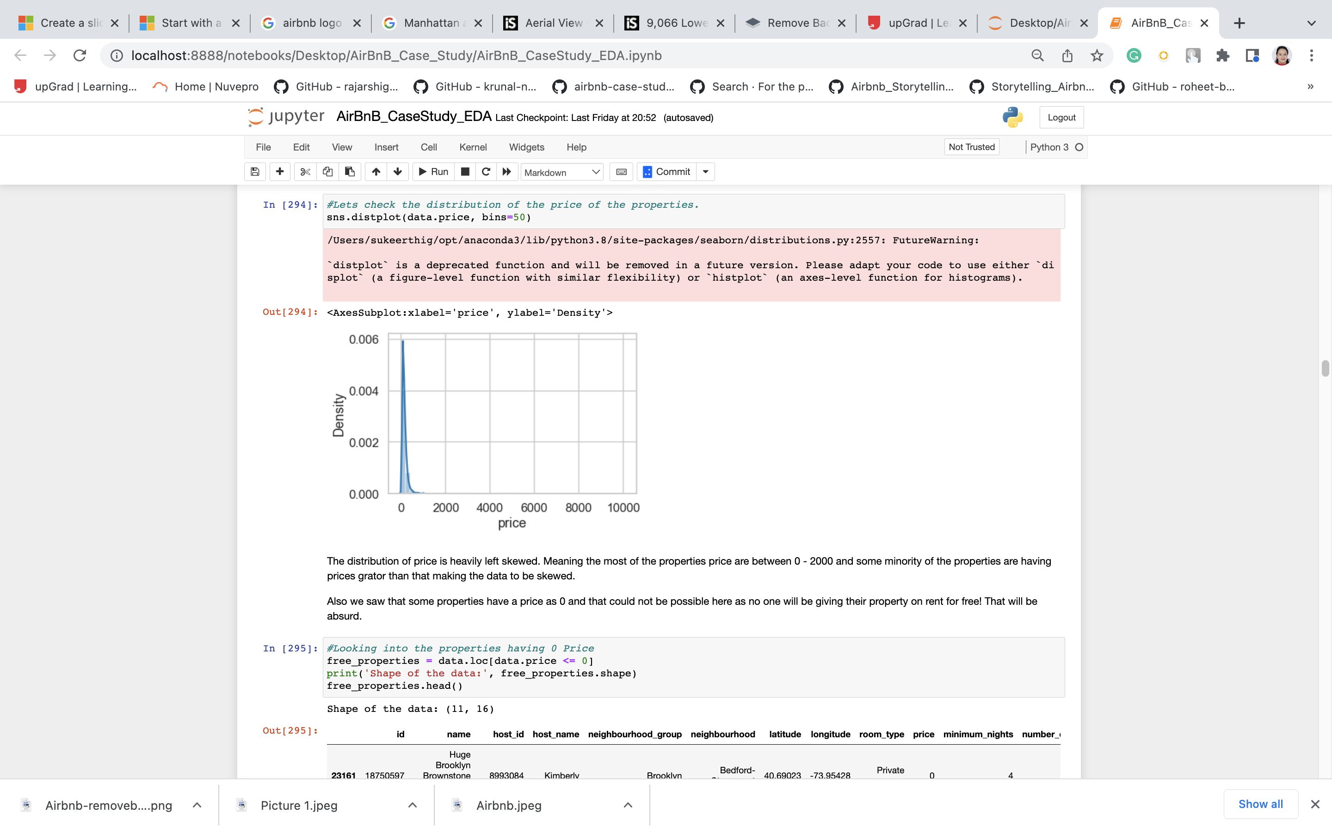



* The distribution of price is heavily left skewed. Meaning the most of the properties price are between 0 - 2000 and some minority of the properties are having prices greater than that making the data to be skewed.

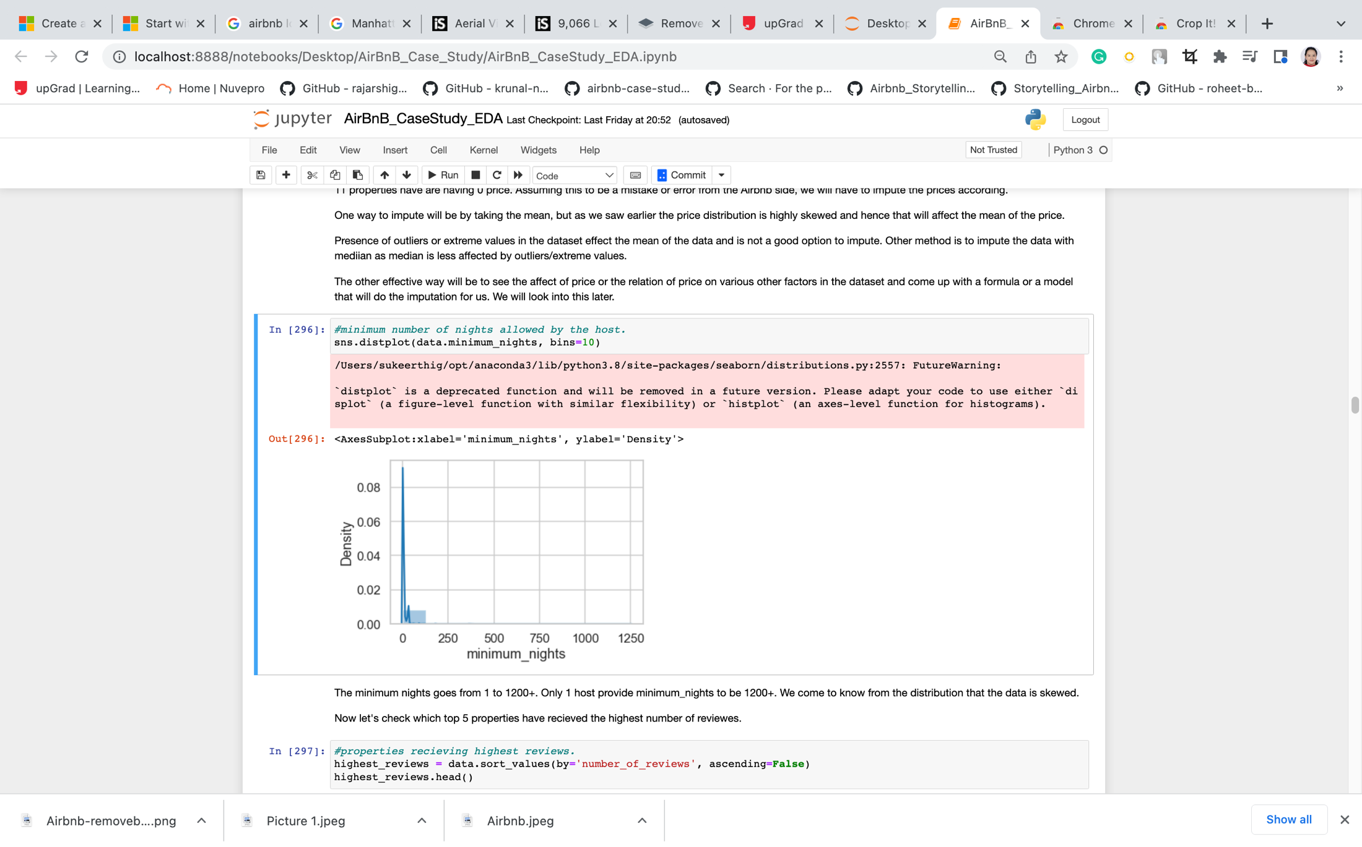

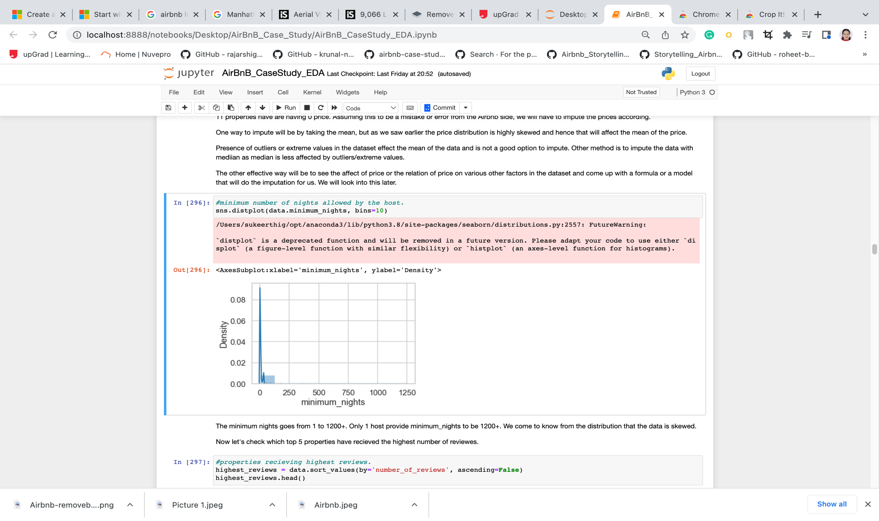

* The minimum nights goes from 1 to 1200+. Only 1 host provide minimum_nights to be 1200+. We come to know from the distribution that the data is skewed.
* Now let's check which top 5 properties have received the highest number of reviews.

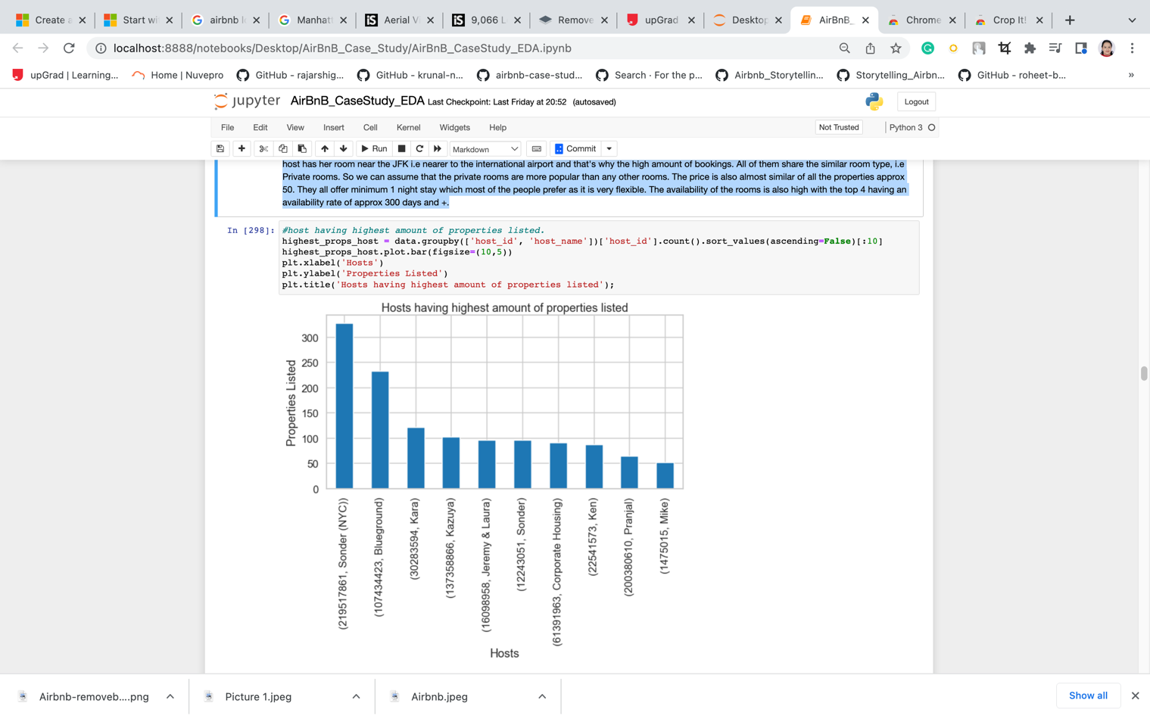

We can see that Sonder(NYC) has the highest number of properties that are listed but his property was not in the top 5 highest reviews table we saw earlier.

This means that the number of properties listed on the Airbnb does not mean that the number of customers you will have will be more.

1. **Bivariate Analysis:**

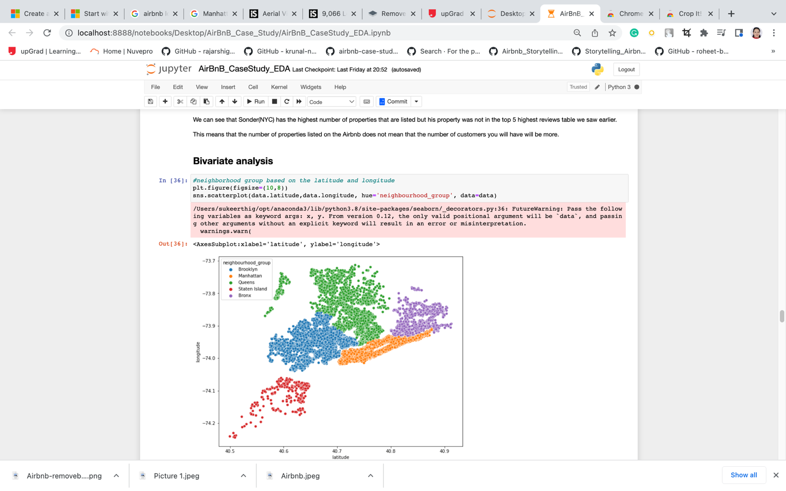

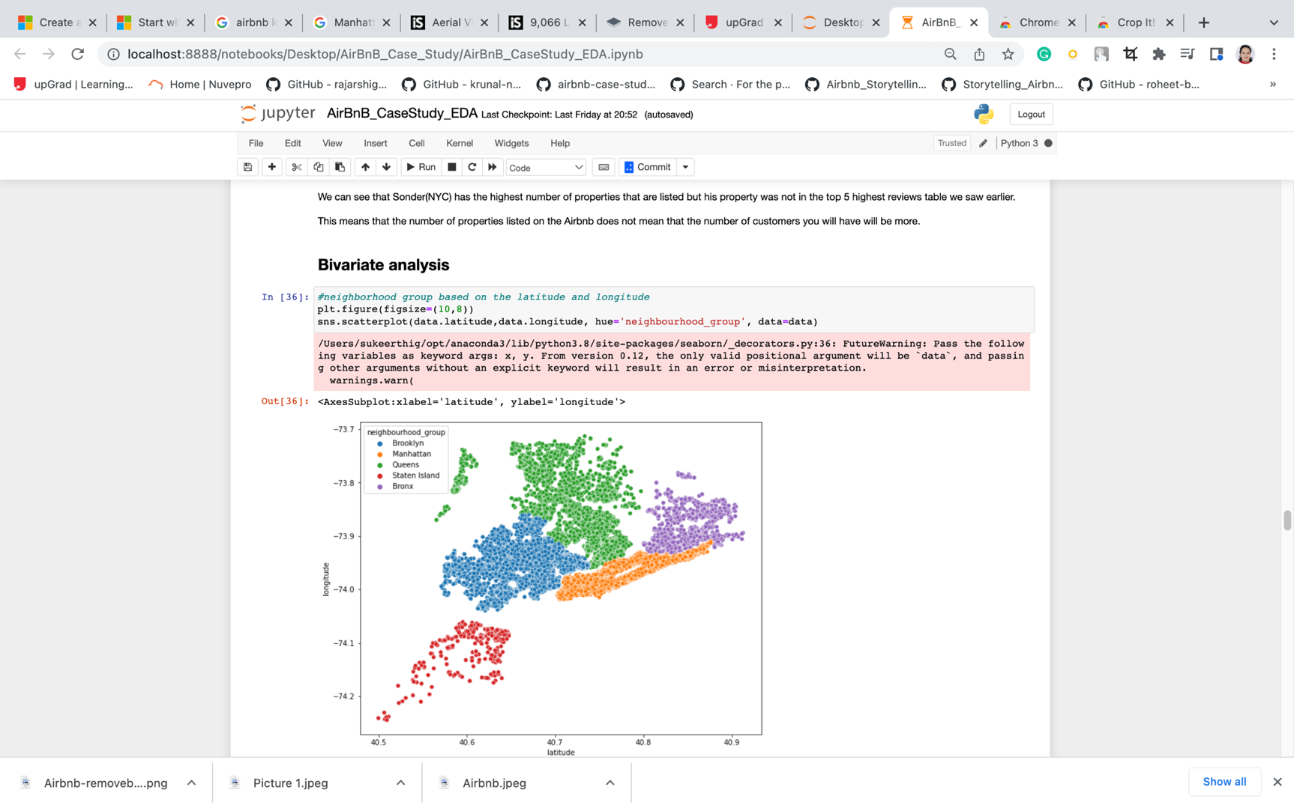

The above resemble the map of NYC and shows the various neighbourhoods and the properties listed in each neighbourhood.

So far we have done some basic exploring of the dataset and have gain few insights from it such as:

* Came to know that the price column had some irregularities such as the minimum price was 0$ which is not possible. Missing values in the last_review column and reviews_per_month column were following a pattern.
* If number_of_reviews was 0 then these two columns had null values. From the univariate analysis we came to know the top 5 neighbourhood which had the highest number of properties listed.
* We also came to know the top neighbourhood groups which had the highest number of properties listed. We came to know the top 5 properties which had the highest review and factors contributing to their reviews.
* We saw the host which had the highest number of properties listed on Airbnb. We saw the distribution of the properties based on the neighbourhood_group on a scatter plot.

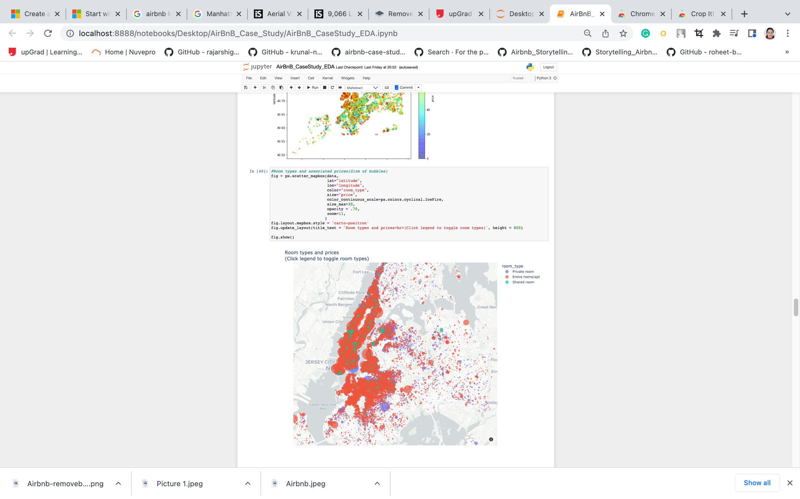

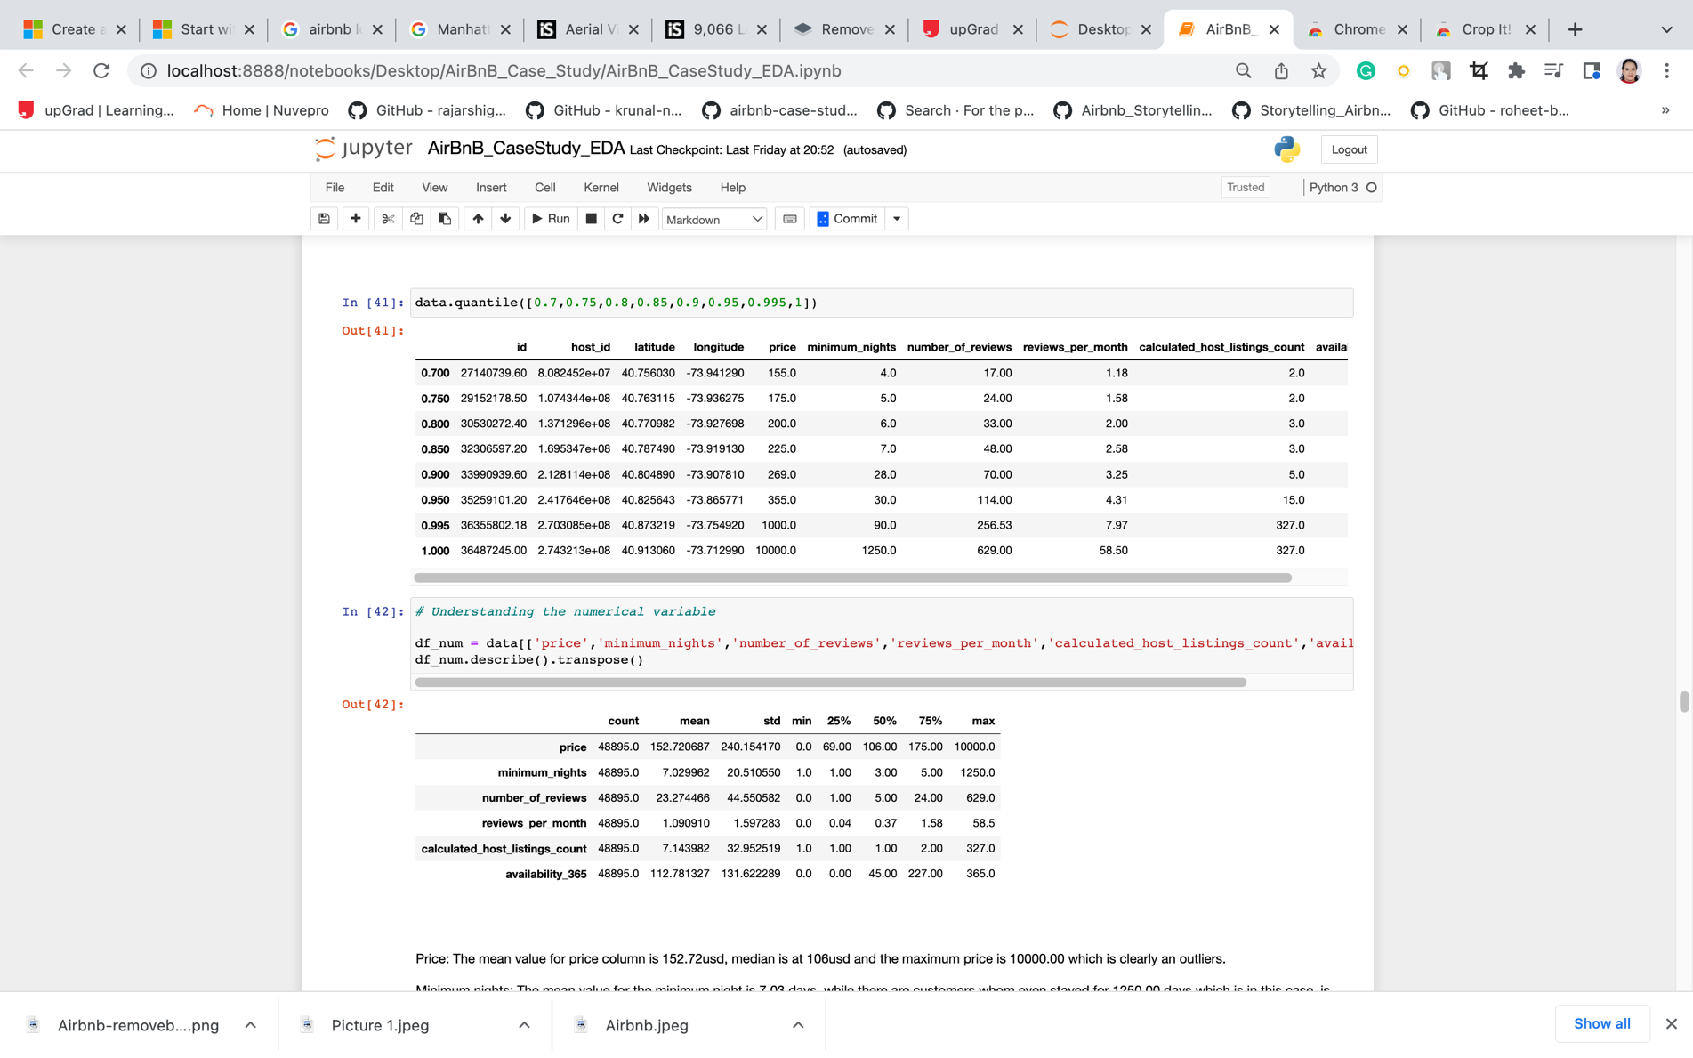

* Price: The mean value for price column is 152.72usd, median is at 106usd and the maximum price is 10000.00 which is clearly an outliers.
* Minimum nights: The mean value for the minimum night is 7.03 days, while there are customers whom even stayed for 1250.00 days which is in this case, is an outliers.
* Number of Reviews: For the number of reviews, the mean values lies in 23.27 reviews, median is at 5.00.
* Reviews per Month: For the number of reviews per months, the mean of the variable is at 1.09 reviews, median is at 0.37 and max number of reviews is at 58.5.
* Calculated host listing account: This is an amount of listing per host, in this variable, 7.14 listing is the mean value, and the maximum listing up to per host.
* Availability 365: For the number of days when listing is available, the mean value is at 112.78 days, median is at 45 days and maximum days is 365.0 days.

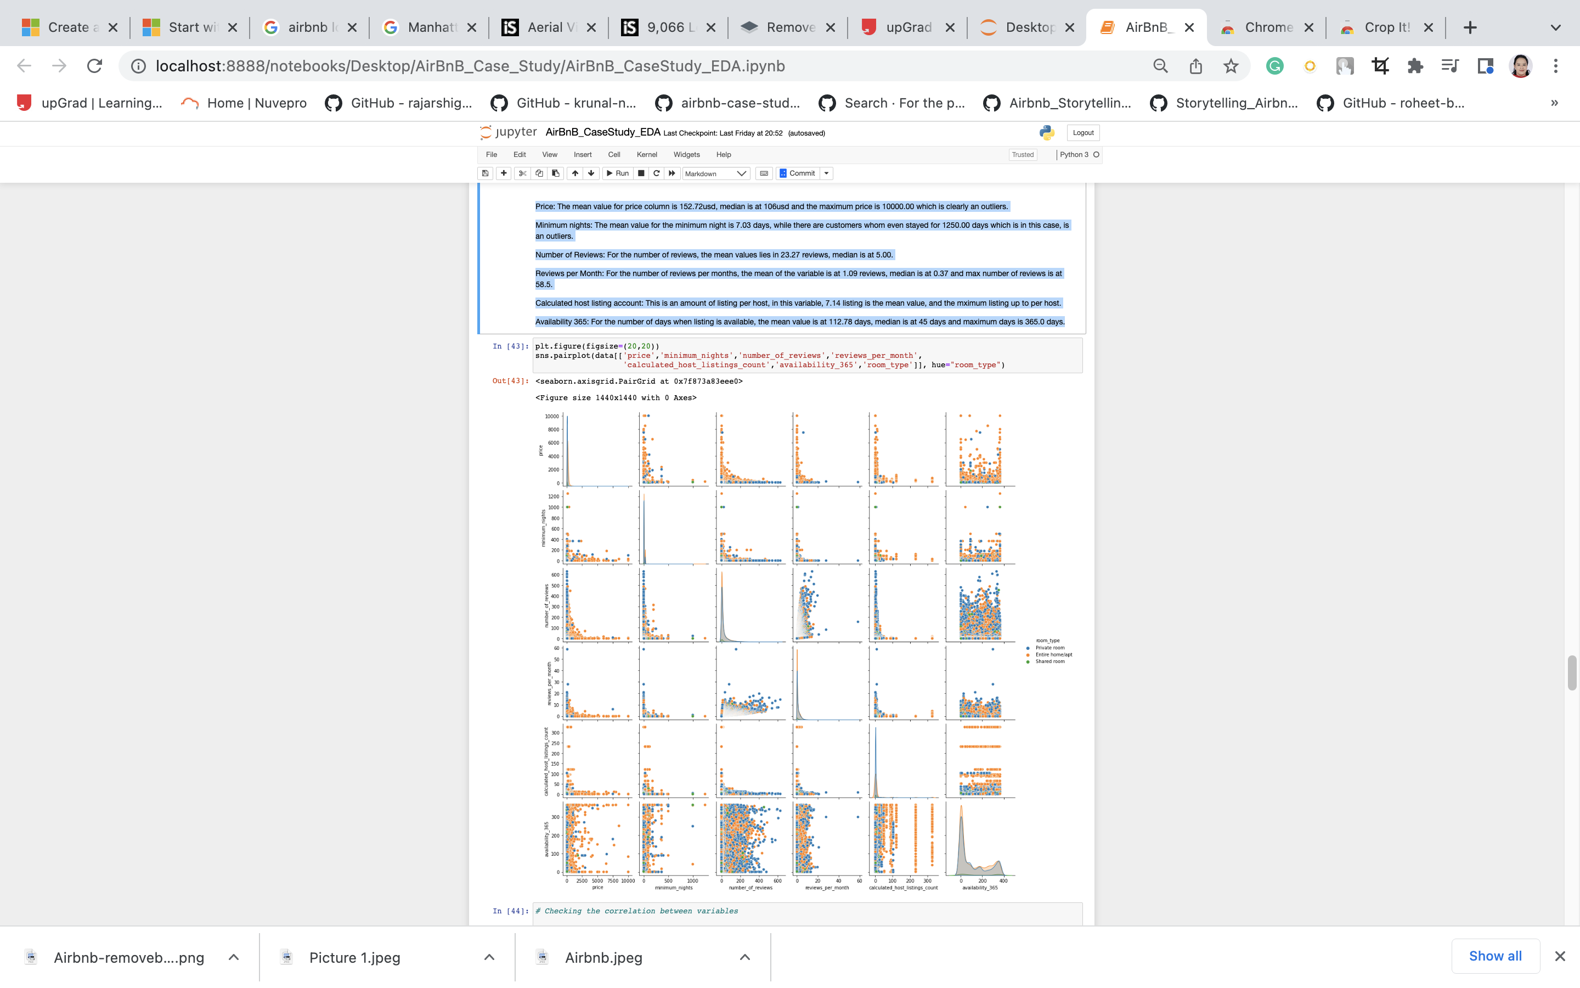

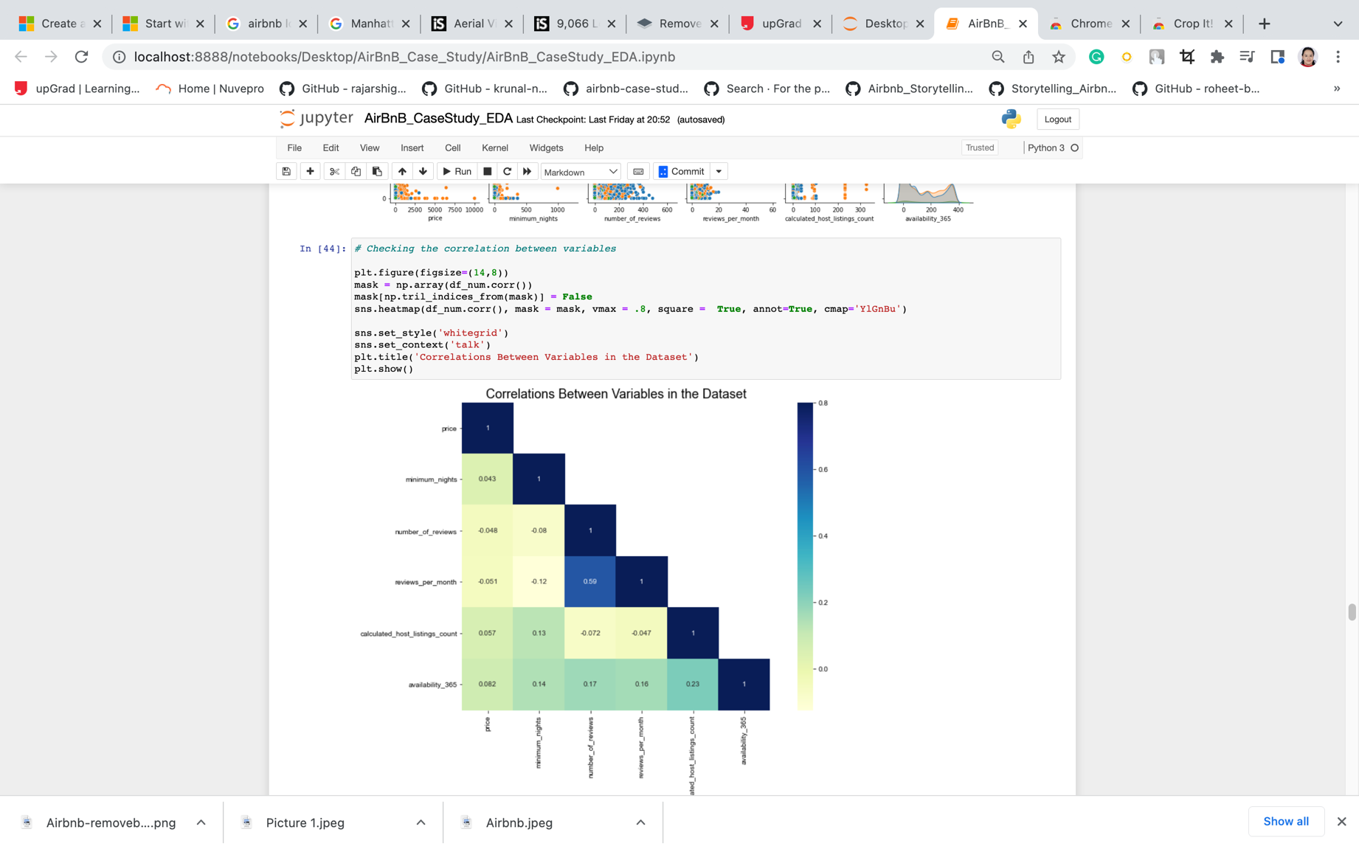

* We can see that the number_of_reviewes and reviews_per_month are loosely correlated.

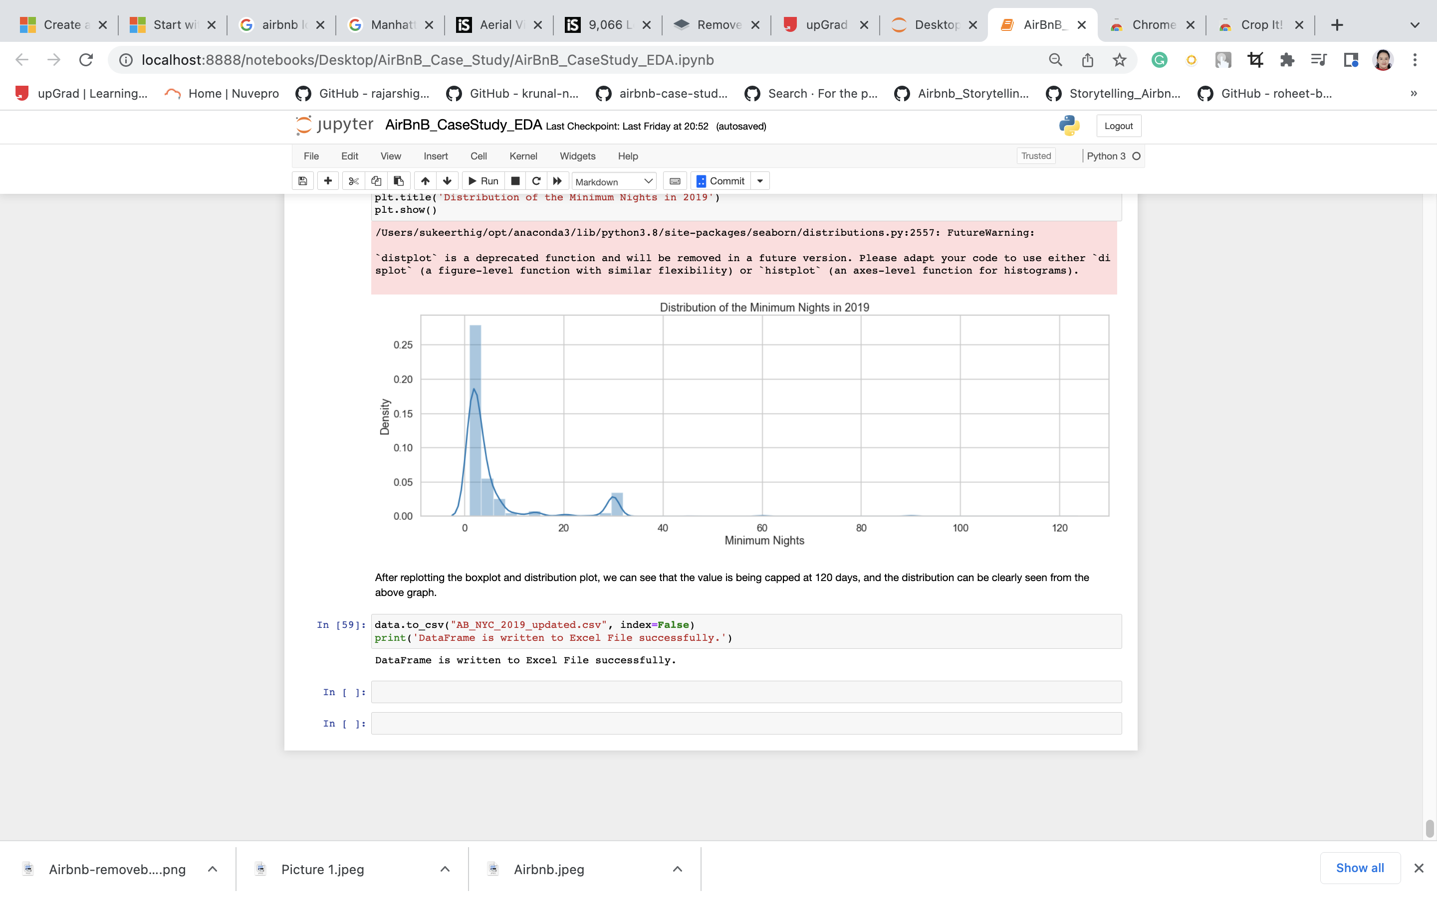

**Data Visualization using Tableau**

1. **Customer Perspective:**



1. **Pricing Perspective:**

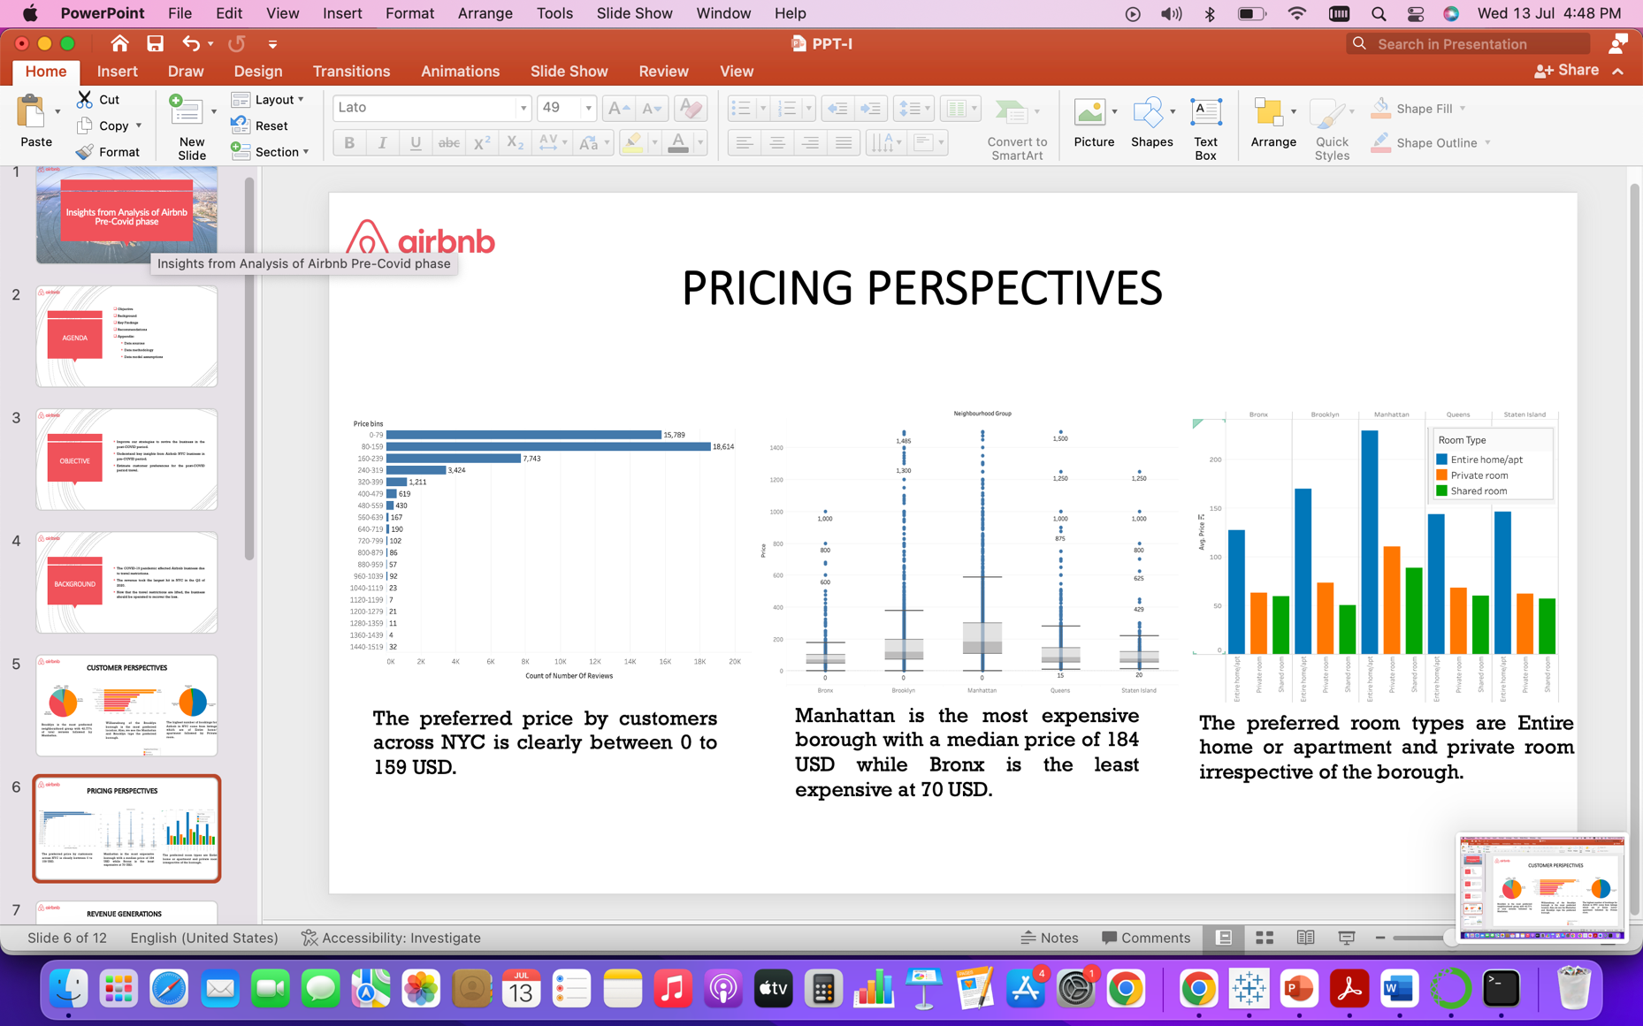

1. **Revenue Generations:**

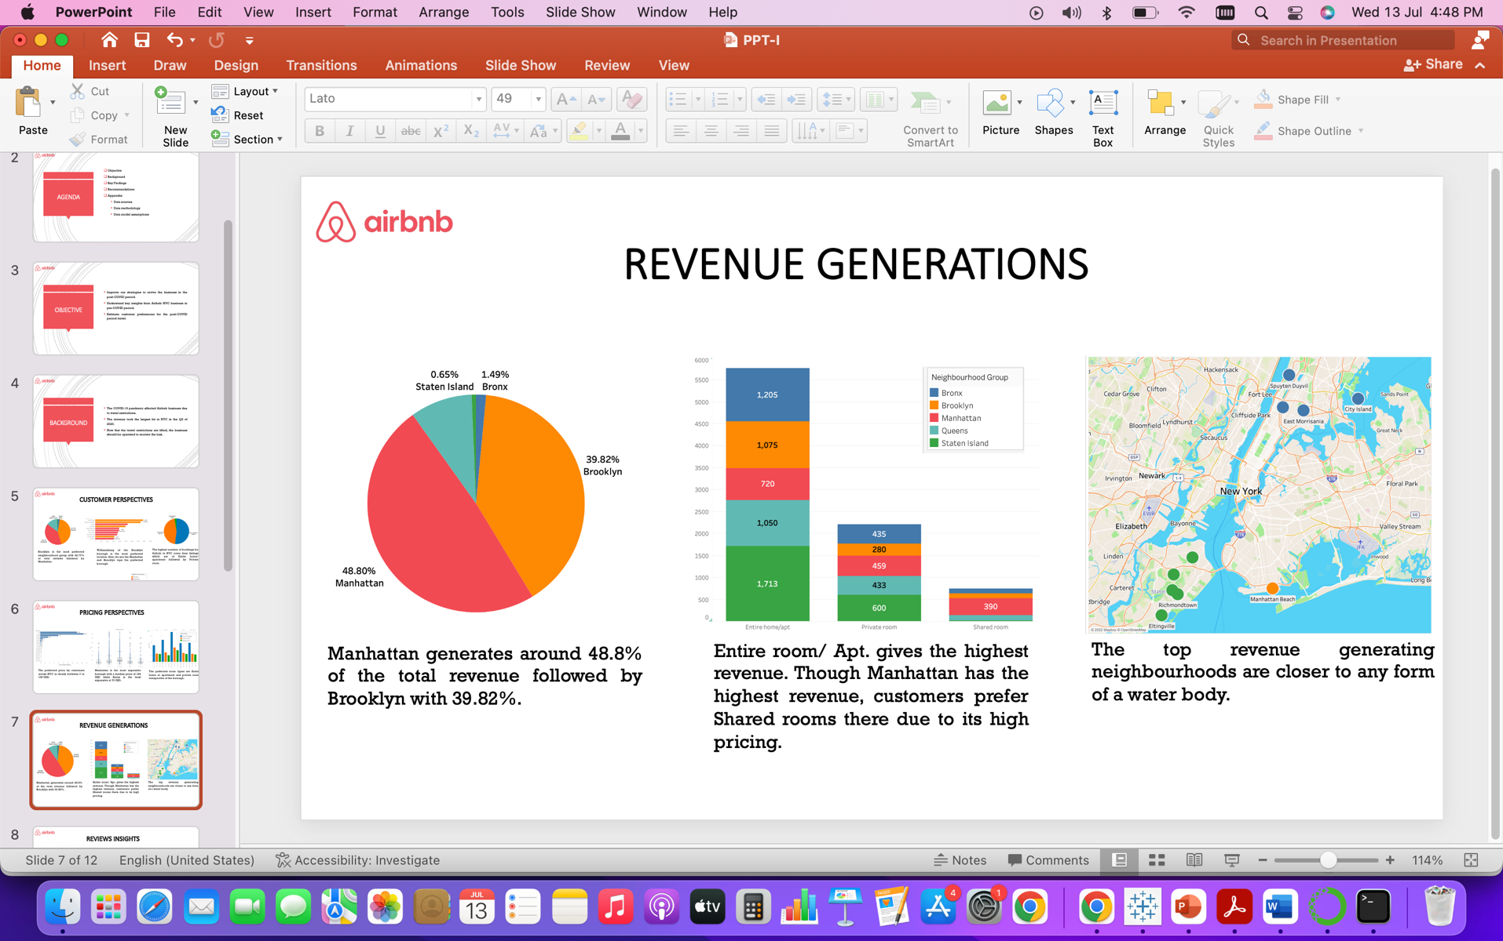

1. **Review Insights:**



**Inference**

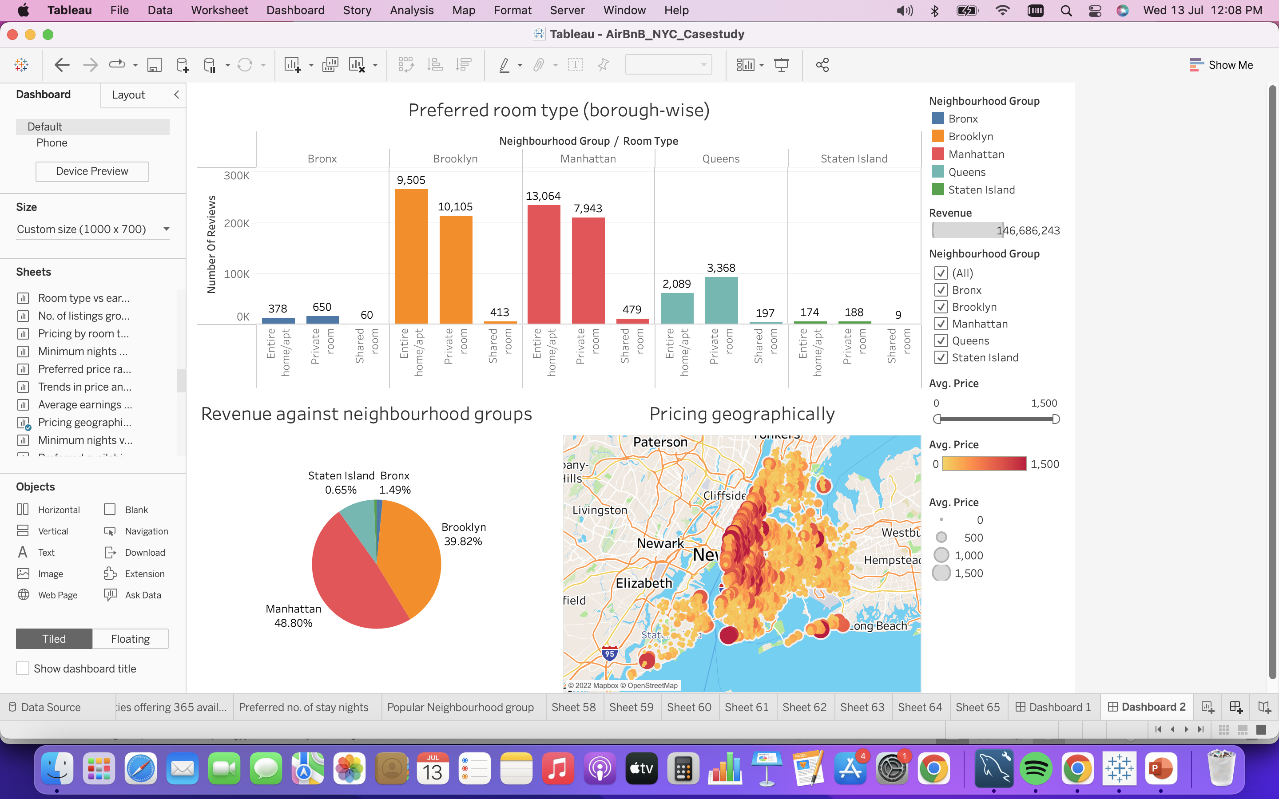

* Increase the number of listings (entire room/apt and private room) in Queens and Bronx due to its proximity to Manhattan and Brooklyn.
* Also, focus more on Staten Island by acquiring many Premium properties and also support the existing hosts to enhance their properties as its potential is left untapped.
* Acquire more shared room properties in Manhattan and Brooklyn as customers prefer a lower price range in these boroughs

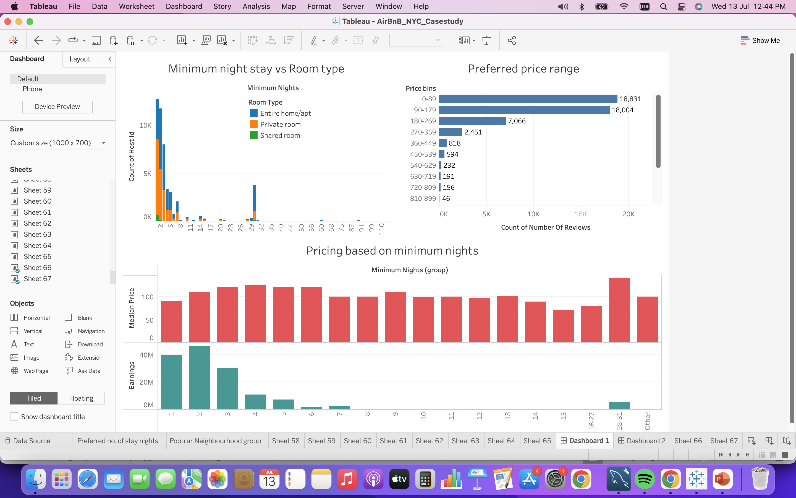

* In the past, it has been observed that majority of bookings are done for apartments, where the minimum number of nights is the least.
* It’s observed that the median price is almost the same for all minimum night stay group. This might discourage customers to book Entire home/apt or private room type in expensive boroughs such as Manhattan and Brooklyn.
* Encourage hosts to offer lesser number of nights stay as it is the preferred one (less than 7 nights and a month stay). Also, discounts for lower minimum nights are an added advantage.

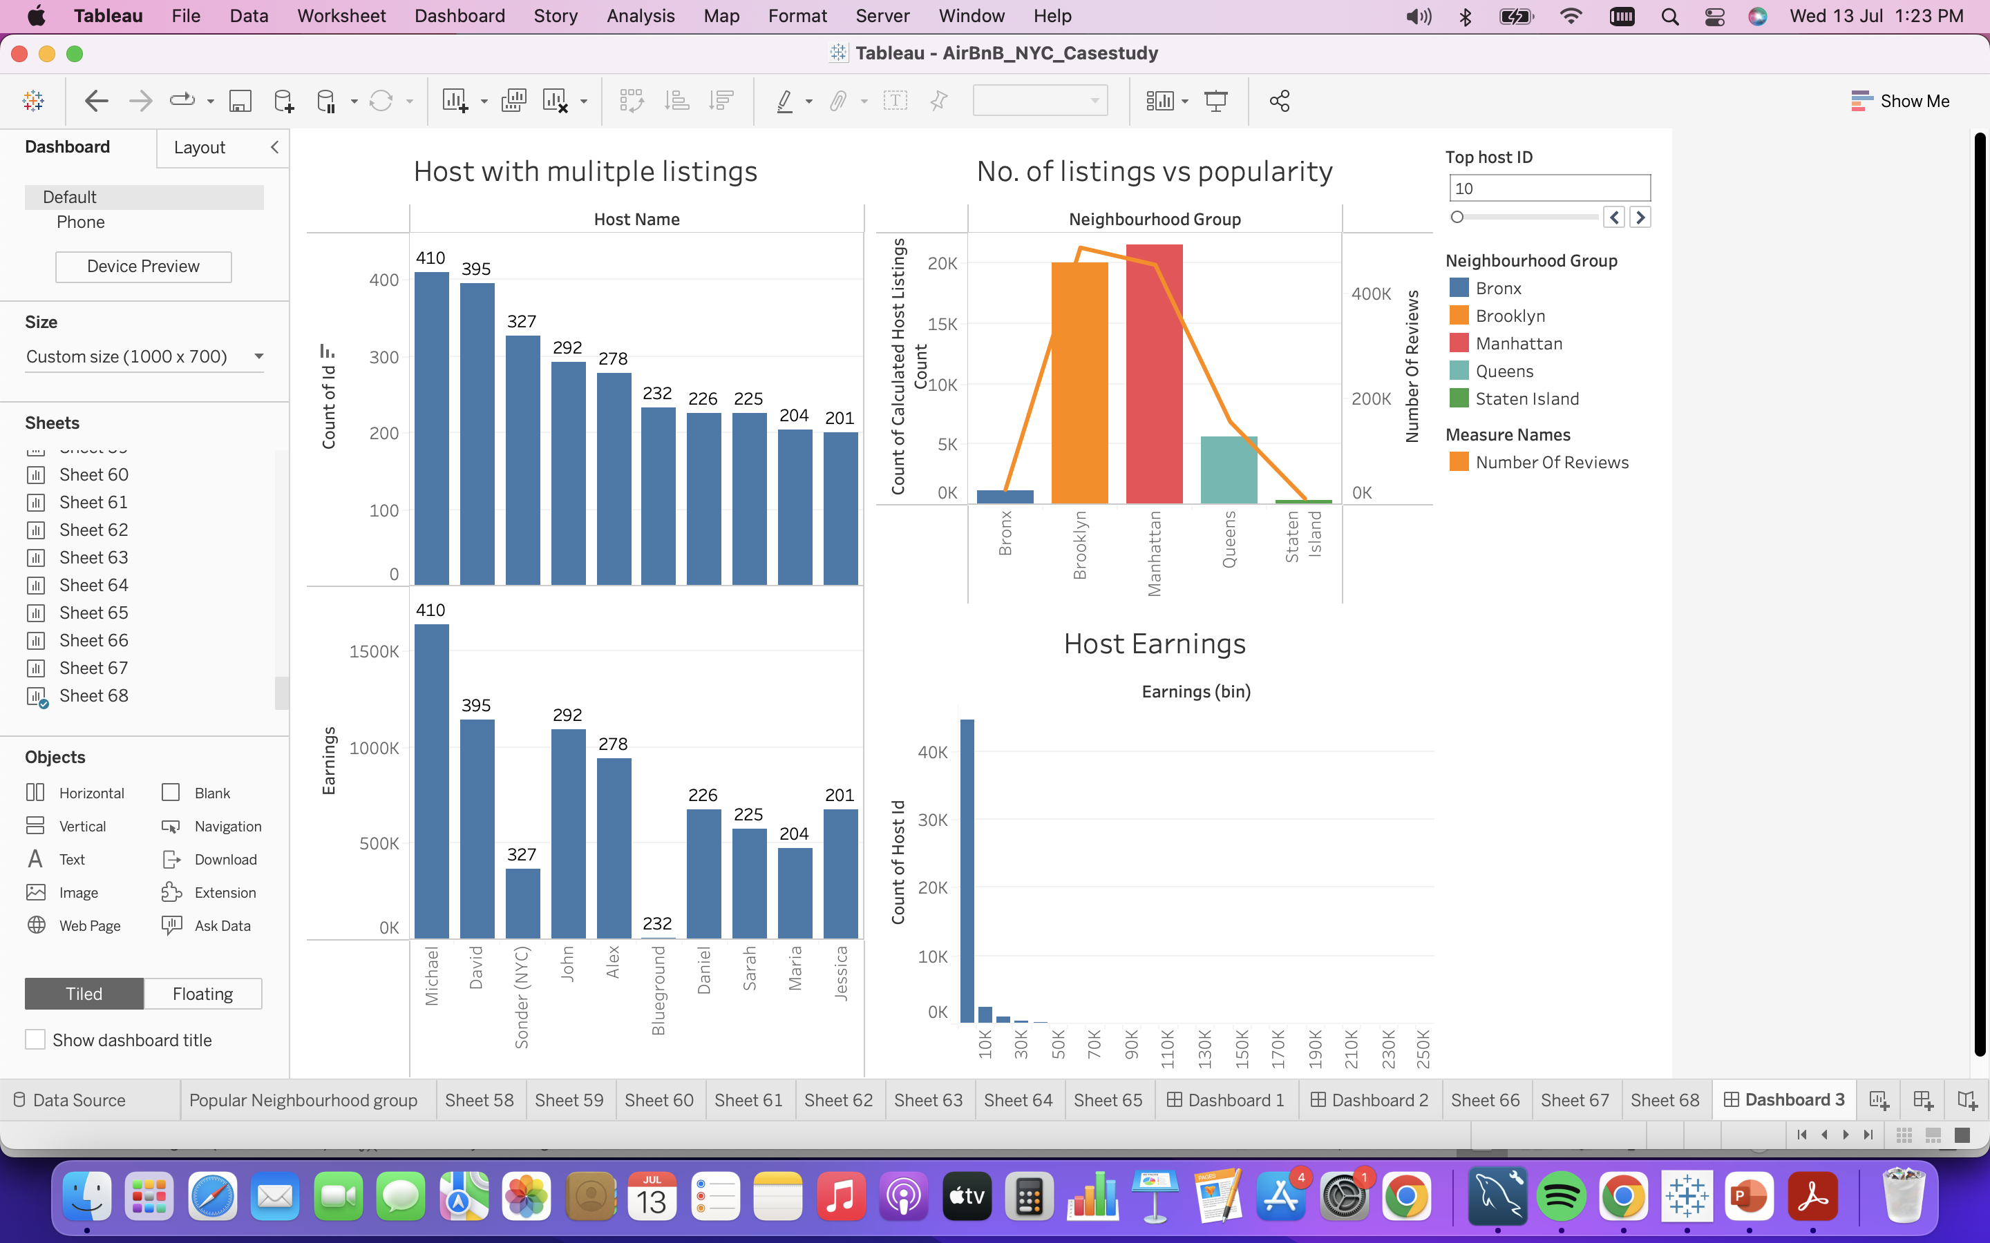

* Higher number of listings by a host doesn’t guarantee higher earnings. Hence, it is highly recommended to improve the qualities of the properties such as cleanliness, digital facilities, food and other relevant facilities.
* Bronx and Staten Island are the next fastest growing boroughs as the others are completely occupied and also expensive for customers. Hence, we have the early bird advantage to utilize the potential.
* The earnings of the hosts are completely skewed to left between 0 to 30,000 USD. Hence, with the above-mentioned findings we can declutter this trend.

**Recommendations:**

1. **Prime Location:** Increase shared room types in Manhattan and Brooklyn as it attracts more customers due to lower price of shared rooms and the scenic view of the borough.
2. **Market Traction:** Increasing the number of listings in Queens and Bronx (Entire home/apartment and private room) helps to attract more customers as it is closer to the prime location
3. **Pricing:** Preferred minimum night stays up to a week (7 nights) and a month (28-31 nights). Hence, introducing offers for such customers can increase traction.
4. **Increase Listings:** Staten Island should be given extra attention by increasing the number of listings especially the sea-side and supporting the hosts to improve the facilities.
5. **Encourage Hosts:** Hosts should improve the quality of their property especially in Entire home/apt and Private Room type as this attracts more customers and hence improves the reviews for the property.